The Saturday Essay

The New ABCs of Business

From administrative assistants (the real office power brokers) to 'reply all' (why you may be fired one day), Stanley Bing offers a modern glossary for workplace survival
By
Stanley Bing
Updated April 11, 2014 11:43 p.m. ET
Words may mean different things in the workplace than they do elsewhere. (Business thrives on imprecision when it suits the occasion.) This makes defining terminology particularly crucial: One must understand what is being obscured as well as what is being said. Here is a partial listing of some especially helpful words to know. The general study of business verbiage, however slippery and challenging, is extremely rewarding for those who believe that it is sometimes important to understand what other people are saying.
Administrative assistant is the servant and master of senior management. Though all the trappings of everyday work are there—the computer, the phone bank, the piles of incoming and outgoing paper—the real function of the job is to grant or block access. More than any other player in the infrastructure, AAs are both high and low. They feel this status acutely. Treat them as the power brokers they are, and they will sometimes respond in kind. Treat them as functionaries, and you will slowly be expunged from the face of the planet.
Agenda is either the formal rundown of a meeting, luncheon or long weekend in Scottsdale with 300 drunk sales managers or a hidden, dark thing, secret to all but a few. Written agendas are fine, as they go, but people who rely on them too much can be boring. The really interesting stuff takes place in the hidden agenda—a complicated amalgam of needs, demands and dreams that make all conversations, even in business, human.
Anger can be good for you: Those who are never infuriated aren't paying attention. But an excess of anger demonstrates bad self-control.
Ass-covering is a craft, not an art. There's nothing pretty about it. Make a habit of documenting situations that have a scent of peril about them. Copy the lawyers. Don't apologize for anything. Apologies are the antithesis of ass-covering.
Breakfast is a low-risk start to a high-risk day, though primarily a marvelous opportunity to have free bacon. The real agenda of the breakfast is friendship. Only hard-bellied moguls have breakfast with people they don't like.
Business is what we all do for a living. Running a gas station is business. Selling lemonade on the street is business. Writing for an online publisher that pays a penny a word is not business. It's stupid.
Capitalism is an economic system in which the means of production are owned by private individuals and corporations (and their stockholders). These relatively few individuals share in "profits" and employ the majority of citizens, retaining their services for "wages." Profits seem to mount a lot faster than wages. Thus, capitalism appears to come most highly recommended by those at the top.
Competition is a pain in the neck. The entire drift of American business is a slow slide to consolidation. That effort will never be entirely successful, though. So in the end there will be 10 or 12 massive, government-sized conglomerates determined to wipe each other from the face of the Earth.
Content is a fancy piece of terminology for movies, television, plays, videogames, books, magazines, newspapers or any other form of news, information or entertainment that people consume with any of their sensory organs other than their taste buds. Soup, for example, is not content. But a video of soup is.
Luci Gutiérrez
Cost cutters do a lot of things under various euphemistic names, but what they really do is fire people.
Cubicle is a tiny space imposed on powerless workers to take away their individuality and crush them into the role of anonymous cog in a machine run by somebody, somewhere who has access to a door behind which they can take a nap or eat their lunch in peace.
Drinks are one of the most venerated institutions in business life, the glue that bonds gray multinational robots to slick sharks in Hawaiian shirts.
Eccentricity is any expression of excessive personality. Keep it wrapped pretty tight unless you're the big boss. Eccentricity is tolerated in organizations that value creativity. Insanity is frowned upon almost everywhere.
Enemies are the product of success. That doesn't mean it's advisable to collect them, whether they're powerful, wise, stupid, venal or misguided. As long as enemies are viable—that is, have at least one friend in senior management—they are time bombs waiting to go off in your face. If you can't eliminate an enemy by guile or muscle, try cordiality and a little discreet support of their objectives. Once he or she understands that you are prepared to cultivate a slow and enduring hatred, rather than a hot and murderous resolution, your foe may be content to remain a thorn in your side rather than a knife in your heart.
Green is your deep commitment to improve the environment in every way your corporation can, unless its business is totally destructive to the environment, in which case your version of greenness is to sponsor activities that say you're sorry.
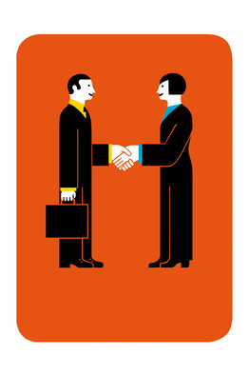
Luci Gutiérrez
Handshake is probably the most important business tool there is. It originated in ancient days when two men wanted to show they were not armed: "Look, Ma," the greeting said, "no club." That function has not changed.
Hobbies are often the sole link between a workaholic and his humanity. The more elevated the executive, the more entranced he usually is with his antique guns, boats in bottles, boats out of bottles, toy banks, salmon farming, antique watches, tiny tin soldiers, telescopes, single-malt Scotches, or yo-yos, just to name a few.
IT is short for information technology. Its specialists comb the corporation, solving computer problems for people in need. As they do, they are secretly planting bugs, worms, Trojans and a variety of devices that will one day be activated by the giant mind of the Internet, incapacitating humankind and ushering in the rise of the machines.
Kicked upstairs is the fate of those who must be deprived of the pleasures and pressures of daily office life through expulsion upward, not downward. To ease the beloved dinosaur into the tar pit, management must afford him a plump post with no authority. Thus we see a bustling president puffed into an impotent chairman with a staff of two, a post from which he is free to take an infinite lunch and play with his paper clips.

The Saturday Essay
Love at the office is a wonderful thing, and don't let party poopers tell you differently. The saucy tang of naughty indiscretion adds bite to the affair, and the ferocity of unchained emotion is thrown into high relief by the drab environment in which it has exploded. Like all romances that take root in a highly specialized world, however, your office love may not survive transplantation into other social milieu, cities or jobs. So enjoy it while it lasts—and if it lasts forever, bravo.
Loyalty is highly valued in all cultures, sometimes to the exclusion of all other attributes. Where it doesn't exist, things well and truly suck. Remember: A corporation is organized to make money, perpetuate itself unto a thousand generations and grow like a weed. Its ultimate loyalty has been and always must be to itself.
Lunch is a perfectly serviceable business institution that has been allowed to bloat into a behemoth of unmanageable size, frequency and duration by professional hedonists who have elevated its marginal status to Olympian proportions. Try to be one of them.
Managing down is the art of getting subordinates to do what you want. Nobody cares that you didn't do the work. You managed it. That's all that counts, especially to other managers.
Managing up is the art of getting your superiors to do what you want. Those at the top are no less in need of good management than those in the lower branches of the corporate tree. The problem: There's nobody around to manage them unless their subordinates do it.
Meetings are essentially odious. Try to have as few as possible, but never miss one you should be at. If it isn't your meeting, you will have to contend with several challenges:
Neatness in nonfascist institutions doesn't count, so long as you don't harbor rotten fruit in your drawers, allow dead animals on your desk or lose too many crucial things. A lot of very competent people need clutter to keep their myriad projects before their eyes. To them, chaos means vitality. This insouciance is all very well and good until you toss out your paycheck with your lunch.
Networking occurs when people get together to try to get something from each other, which makes it very anxiety-producing and boring if you don't want anything from anybody.
No is a serious profanity in business. You seldom want to say it. Better to just say "Yes" or "Maybe" and do nothing about the matter until it goes away.
Nodding is a key ingredient of your pleasant persona. Good nodding soothes people and lets them know you're paying attention even when you're not. In open meetings, where you can almost doze and not get caught, it may be wise to interject an occasional comment like "Huh" or "No way" to show you're in the same room.
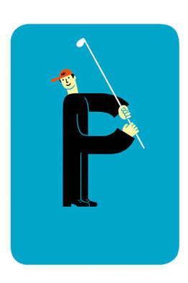
Luci Gutiérrez
Parent is the organization that owns the organization that owns the one that owns yours. Parents are gray and sober of mien, and they tend to nag a lot. This parent could also divest you without a tear or make you travel to Dubuque in the winter. So it pays to make a big fuss when it visits and to tread lightly when you are a guest in its home.
Perks are all the goodies your company lavishes on you at their discretion. Included are caps, jackets and the occasional Clippers ticket for lowly types; posh hotels, unlimited access to golf, tennis junkets and Lakers season tickets for high middle management; and airplanes, cars and new spouses for very senior people. The best perk of all is a flexible and mighty slab of plastic in your wallet and a controller who signs off on your expense account without reading it too closely.
Power corrupts, and absolute power corrupts absolutely. Big deal. It's good to have some. Quite a few people can't manage it very well, but these tend to be egomaniacs with a thin shell of grandiosity. Unalloyed with ambivalence or conscience, it may also be evil. And although there are certainly evil people around, the vast majority of harm is done by decent people convinced of the absolute correctness of their positions.
Reply All is why you may be fired one day.
Revenge, they say, is a dish best served cold. It is also delicious raw, slow-cooked in a Dutch oven, parboiled, baked or fricasseed.
Salary is what they pay wage slaves. Successful players receive compensation. That includes goodies that people who simply receive a salary know not of. When you hear that a beneficent executive has voluntarily decided to receive just one lone dollar in salary, find out how many options and Restricted Stock Units he or she is receiving. It can be a nauseating sight.
Sales is the activity of making another person buy something he or she didn't know they wanted. A sales career is not for everyone: Failure is bleak and terrifying, a gaze into the essential alienation of existence. Success, on the other hand, is sudden and almost sexually gratifying.
Social media is linking all human life on the planet into one gigantic brain stem throbbing with unintelligible thought.
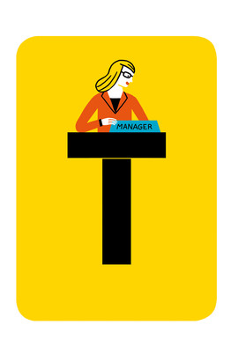
Luci Gutiérrez
Title is very, very important. Don't let anybody tell you different. A new title—particularly one that is publicly announced—is worth a ton more than a lousy 5% raise. If they don't want to give you a quantum shift from associate to manager, take an incremental elevation to something like senior associate. If you're already a senior associate and they won't make you a manager, fight to be a senior executive associate. And money will eventually follow, falling out of the upper regions of the corporation as those who determine compensation forget your title change was meaningless and simply look at all those adjectives in front of your name.
Travel is really fun for about 10 years. Then you get tired of bouncing on the bed. Fortunately, as the rigors of the traveling lifestyle begin to wear, you will be growing in power and status and eligible to stay in ridiculously sumptuous surroundings on sheets with a high thread count.
Winning is great for people who believe they are playing a game. Quite a few do, but it's a limited analogy. A game is a structured activity, defined by rules, determined probabilities and skill. The world of business does share some of those characteristics, but at its heart, it is an arbitrary pageant of rampaging human folly, interpersonal manipulation and occasional grandeur. All central decisions—no matter how they may seem based on metrics and analysis—are, at the moment of their birth, irrational, visceral, a leap into the void. So don't play solely to win. Play to make something grow. And if you win a lot along the way, so much the better for you and all who rely on your wisdom, creative spirit and money.
Workaholics are not people who work hard. Workaholics are people who replace life with the appearance of work. Much of what the workaholic does isn't work per se. It's activity—Brownian motion. Up to a certain point, workaholics must be pitied, for they are the prototypical victims of their own success. After that, they're just crazy people getting between you and your dinner, kids and poker game.
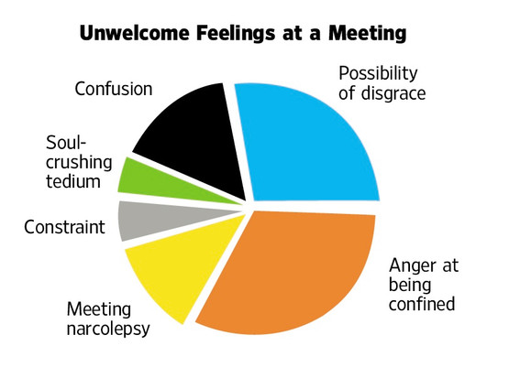
Stanley Bing is the pen name of a long-time columnist for Fortune magazine and the author of several best-selling books on business strategy. This piece was adapted from his new book "The Curricululm: Everything You Need to Know to Be a Master of Business Arts," which will be published this week by HarperBusiness. By day, under his given name, Mr. Bing is a senior officer of a large corporation.

