Walt Disney, a Visionary Who Was Crazy Like a Mouse
By NEAL GABLERSEPT. 12, 2015
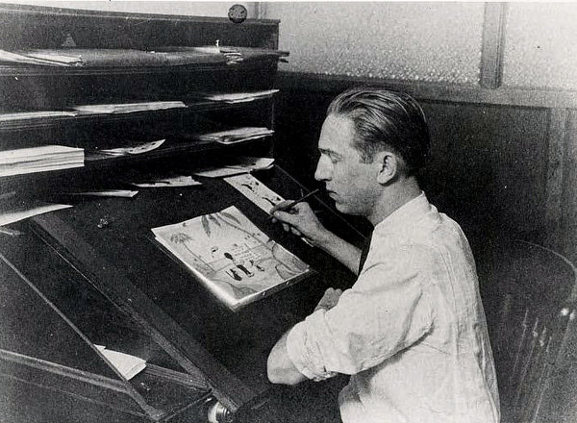
Walt Disney working on a sketch for Laugh-o-Gram, an early venture that made comic shorts based on fairy tales. Credit The Baron Missakian Collection, via University of Missouri-Kansas City
Here is something that might surprise you: Walt Disney, that icon of American ingenuity, was in financial straits through most of his career. You probably thought he would have been a business genius — a model for others to study. But Disney was an atrocious businessman, constantly running his company into the ground. At the same time, though, he was a corporate visionary whose aversion to typical business practices led to the colossus that the Walt Disney Company became.
Before he was even old enough to legally sign the incorporation papers, Disney wrangled a few friends together, raised some cash and started Laugh-o-Gram, a studio in Kansas City, Mo., that made comic cartoon shorts based on fairy tales. But he seemed less interested in making money than in having fun, and the company promptly went bankrupt, sending Disney, by then 21, to Los Angeles to look for work in the film industry.
Continue reading the main story
He was saved when a New York distributor picked up a short he had made, featuring a real-life girl named Alice who lived in a cartoon world. Things went swimmingly for a while, even when the Alice films ran their course and Disney had to invent a new hit character, Oswald the Lucky Rabbit. But Disney was both financially reckless and egotistic. His distributor doubled-crossed him, surreptitiously poaching his animators, who bristled at his highhandedness. Since the distributor owned the rights to Oswald, Disney, then 27, had to start from scratch again.
Photo
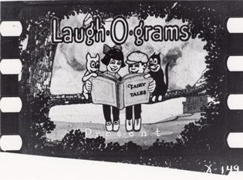
A video still from the Laugh-o-Gram cartoon "Jack the Giant Killer." Credit Walt Disney Productions
He replaced Oswald with a new invention: Mickey Mouse, an instant success. But as his creativity continued to flourish, his business acumen flagged. Even Disney’s older brother Roy O. Disney, who oversaw the infant studio’s finances, said his brother would have been constantly fleeced were it not for him. In the case of Mickey Mouse, he was. A New York businessman named Pat Powers finagled Disney into contracting for his sound services — with onerous terms. Even though the Mickey Mouse cartoons did well, by the time Disney paid Powers his enormous cut and the studio’s expenses, there was very little left. Only when Disney persuaded Columbia Pictures to buy the distribution rights for a second series of cartoons called “Silly Symphonies” did he get a steady cash flow. In time, Columbia also secured from Powers the rights to the Mickey cartoons.
Disney could have expanded the company steadily, building on the success of Mickey Mouse. Instead, he placed a huge and highly risky bet on feature animation. “Snow White” was four years in production and cost over $2 million ($33.5 million in today’s dollars), most of it borrowed from Bank of America against the receipts of the cartoon shorts. The gamble paid off. “Snow White” earned nearly $7 million ($117 million today), most of which he immediately sank into a new studio headquarters in Burbank, Calif., and a slate of features.
Photo
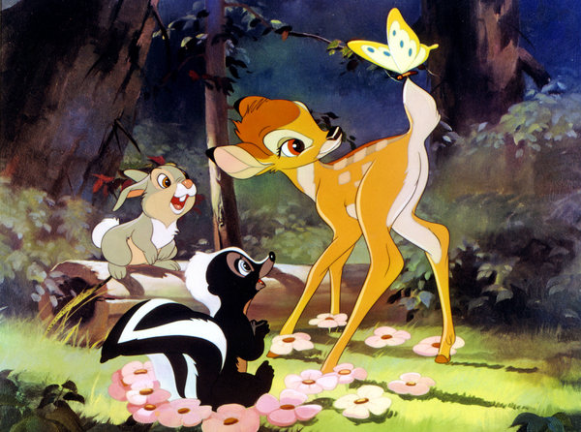
"Bambi," released in 1942, was an expensive dud for Disney. Credit Walt Disney Productions
But as hard as it may be to imagine now, these new films — “Pinocchio,” “Fantasia” and “Bambi”— were expensive duds, as World War II damped the European market and audiences’ interest in feature animation waned. The losses were catastrophic — $1.5 million on “Pinocchio” alone, or more than $25 million in today’s dollars. Owing millions to Bank of America, the company was once again in financial trouble, and it survived the war only by forgoing big animation and instead producing training films and propaganda for the government.
Advertisement
Continue reading the main story
Advertisement
Continue reading the main story
But survival was all it was. Disney, who after the Oswald debacle insisted that he would never yield control, sold stock to investors and later briefly brought in an outside management team. He even hired efficiency experts to determine whether animation could be streamlined. In the postwar period, the studio turned out films that Disney himself considered inferior. And it took an emergency loan of $1 million from Disney’s feature distributor, RKO, to stave off collapse yet again.
Photo
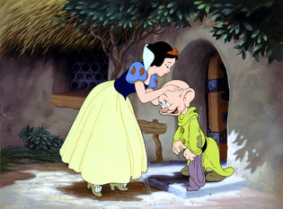
"Snow White," released in 1937, was a big gamble. It cost over $2 million to make, but paid off by earning $7 million, about $117 million in today's dollars. Credit Walt Disney Productions
Disney made the situation worse by voicing his contempt for the financial types that bailed him out. He didn’t care one whit about money. Even his wife, Lillian, complained that she didn’t understand why he didn’t have more of it. After all, she said, he was Walt Disney. Had he not been the studio’s creative force, had the studio not been so closely identified with him, he almost certainly would have been ousted. As it was, both the bankers and his brother pressured him to rein in his ambitions and compromise on the quality of his films.
And yet for all his financial difficulties, Disney resisted compromise. Yes, the animations might lose money in the short run. But, unlike so many businessmen, he played the long game. As early as 1936, he refused a distribution deal because it included television rights that he wanted to retain. And not long after, he instituted the idea of rereleasing the features every five years — which ultimately brought prodigious profits.
Quality proved to be a great morale-boosting strategy as well. Until a bitter strike in 1941 shattered the studio’s sense of camaraderie — a strike that Disney blamed on Communist instigators — animators fought to work at the studio because they wanted to be part of Disney’s artistic mission.
And though Disney’s capriciousness and constant reinvention of his company drove his brother and others crazy, it also kept re-energizing the Disney studio and led, in 1955, to Disneyland — a triumph that at last put the company on solid financial footing. Not incidentally, Disneyland sprang from another of Disney’s beliefs: that it was hard to wring greatness from a bureaucracy. He and his team designed the park as a separate entity from the studio, WED Enterprises.
None of this would have been possible without Roy Disney’s understanding that his primary job was to realize his brother’s dreams. He was the businessman whom Disney needed to deal with other businessmen. Walt Disney, at his core, was an artist who tossed out the corporate playbook and operated, as artists usually do, by inspiration. In the end, the company flourished precisely because Disney was such an indifferent businessman.
Neal Gabler is the author of “Walt Disney: The Triumph of the American Imagination” and an adviser on “Walt Disney” for “American Experience,” which is on PBS on Monday and Tuesday nights.
A version of this article appears in print on September 13, 2015, on page BU4 of the New York edition with the headline: A Visionary Who Was Crazy Like a Mouse. Order Reprints| Today's Paper|Subscribe

