Journal Reports: Leadership

Advertisers Use Social Media to Promote Brands in Real Time

Advertisers Watch What's Trending—and Craft Content to Match
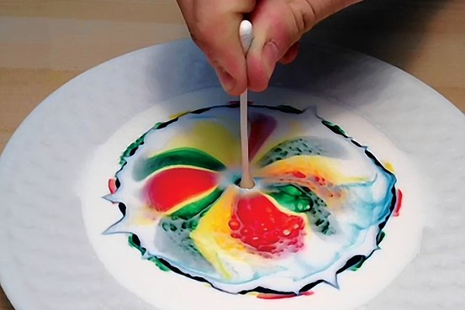
A still from a video posted by General Electric on Twitter's Vine app, showing how color moves through liquid. The video has been liked by more than 227,000 viewers, spreading awareness of the GE brand. General Electric
The usual formula goes something like this: Marketers and advertisers spend huge budgets to craft their campaigns, then refine them over weeks or months until they find just the message that will reach their target audience.
Now some companies are trying to squeeze all of that work into mere minutes.
These advertisers are watching Twitter and other social networks to see what topics are getting the most attention, and putting together short blog posts, tweets and videos that match those themes—in hopes that the online audience will become more aware of the brand and see it as relevant to their interests and needs. Then, if one topic isn't getting attention anymore, the companies can drop it without much fuss, and switch gears quickly to follow the next hot discussion.
Consider what Bank of America Corp. did during the World Economic Forum in Davos, Switzerland.
Experts from the bank's legal, social-media, marketing, advertising and other departments scanned 60-inch screens at brand agency Digitas Inc. late into the night to see what was trending on Twitter.

Related Video
WSJ's Suzanne Vranica and Mike Shields discuss the rollout of the Journal's new vertical section, CMO Today, which will focus on the radically changing marketing industry. Go to http://blogs.wsj.com/cmo/
Their mission: to promote the bank's brand among people interested in economic issues by publishing real-time content related to the conference. During a session on women, for example, with #davoswomen trending on Twitter, the bank's team tweeted a link to a Merrill Lynch paper about the growing economic influence of women.
"The data comes into the room from many sources, and you have to use that data like a modern-day orchestra leader, blending the inputs in real time in a combination that is as much an art as a science," says Louis Paskalis, Bank of America senior vice president.
The bank's attempt to use the conference to promote its brand seems to have paid off—97% of people who clicked on BofA's content on social media during the economic conference were engaging with the bank for the first time, Mr. Paskalis says.
To figure out the best ways to manage real-time campaigns—and what pitfalls to avoid along the way—The Wall Street Journal recently spoke with a number of marketing and advertising experts. Here's some of their best advice.
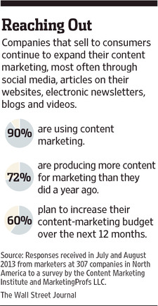
Experiment with new types of media. General Electric Co. started sharing content on Vine—a service that allows users to post short looping videos—the day Twitter introduced it, even though it was an unproven strategy, says GE's head of global brand marketing, Linda Boff.
Ms. Boff's team constantly monitored how the videos were being received on Twitter. If the videos didn't perform well, the group was prepared to pull the plug. "That's the beauty of this type of media—it's fairly easy to produce, and fairly easy to monitor," Ms. Boff says. And if you do shut down the project, "you've wasted a very small amount of time."
An early video—a clip that showed how color moves through liquid, using a saucer of milk, food coloring, dish soap and a Q-Tip—paid off. It has been liked by more than 227,000 viewers and GE turned it into a weeklong campaign promoting experiments tagged with the hashtag #6SecondScience.
The payoff, say Ms. Boff, was spreading awareness of the brand. "Being accessible, humanizing our social channels and joining these conversations is a way for people on Twitter to become more familiar and more excited about the company," she says.
Follow conversations, then join them. Companies should look for people who are tweeting about the company's core strengths and see what's on their minds.
Ms. Boff's team, for instance, searches on Twitter for hashtags and conversations about science. When the companies have a sense of the kind of content that these communities care about, they can craft similar content and tweet it, perhaps using the same hashtags these communities are using.
"We try to behave the way you would if you were meeting somebody in a social gathering—you don't accost them, instead you try to find a commonality of interest," Ms. Boff says.
A Bank of America team scanned screens at the brand agency Digitas during the World Economic Forum to see what was trending on Twitter. Chute
Practice restraint. Saying no is a discipline—maybe the most important thing in real-time marketing, says BofA's Mr. Paskalis.
Rather than publish content on a huge range of topics, focus on where your brand has built expertise and can add the most value to a conversation. GE, for example, sticks to messages about science and technology on social media—rather than try to sell its products or take shots at competitors.
Get legal permission to use material. There are often situations when it's helpful to post content owned by other people or organizations. Marketers should have a structure in place to get permission quickly, so that they can post their messages before they get stale.
During the World Economic Forum in Davos, for example, Bank of America created advertising spots for news sites that updated in real time. Among other things, the ads showed tweets that the bank didn't create but were related to the conference. So, Mr. Paskalis's team hired content-marketing startup Chute Corp. to reach out to the Twitter users and quickly get their approval.
Be ready to turn off scheduled posts. Social-media managers tend to release automated messages at specific times throughout the day, which usually is an efficient way to ensure the brand is never silent on social media.
This can backfire, however, during disasters like hurricanes or floods, when readers are searching for information on the extent of damage or number of casualties. "Customers want brands to be relevant, not opportunistic," says Paul Berry, CEO of RebelMouse, a platform that helps users combine their social-media posts, articles, videos and other online content into one home page.
Watch for sudden flurries of activity on social media. "When 12 people you respect suddenly all follow one Twitter account, don't ignore it," Mr. Berry says.
Typically, it's a good sign that this Twitter account represents a big player—someone you should at least be aware of. To know when this is happening, Mr. Berry recommends following the Twitter account @MagicRecs, which sends direct-message alerts recommending Twitter accounts based on the activity of those the user is already following.
Move on when content gets stale. When content performs well, it's a good strategy to double down and publish more on the topic. But sooner or later, it's time to move on. For instance, when a tweet that was getting 20 retweets a minute drops down to 10, it's time to find a new topic. "Don't try to score another touchdown when the play is over," Mr. Berry says.
Never ignore negative feedback. If you're losing followers on Twitter, try to figure out why, Mr. Berry says. Every day, his social-media team publishes a report on how the company is doing on all its social-media networks, with a focus on unfollows, new follows and engagement like retweets and favorites. They discuss via email which metrics are up or down from the previous day and why. "Through these threads, we fine-tune the strategy we were working on," he says.
Ms. Wells is a staff reporter of The Wall Street Journal in San Francisco. She can be reached at georgia.wells@wsj.com.

