Waiting in Line for the Illusion of Security
Economic View
By SENDHIL MULLAINATHAN and RICHARD H. THALER MAY 27, 2016
115
Photo
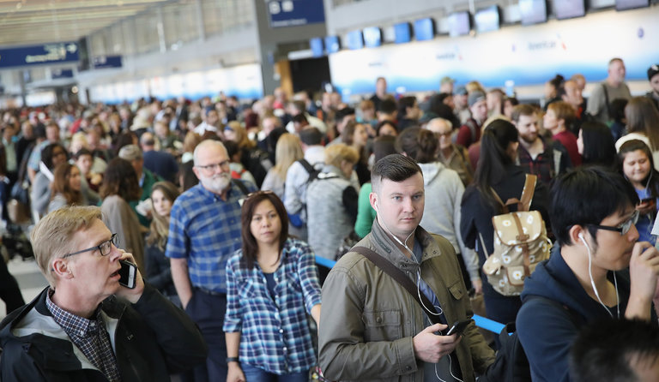
Passengers this month at a checkpoint at O’Hare International Airport in Chicago. With security wait times at some airports as long as two hours, many people have missed their planes and some flights have been delayed. Credit Scott Olson/Getty Images
Interminable lines at airport security checkpoints have caused a great deal of unnecessary misery.
Many people have missed their planes, and some flights have been delayed because too few passengers made it to the gate on time. A video of a two-hour security delay at Chicago’s Midway International Airport generated millions of views.
There are many explanations for what has been happening at the airports, but, as economists, we naturally prefer a basic, economic one: When something is free, it is likely to be wasted. (Think about food left on your plate at an all-you-can-eat buffet.) In this case, the Transportation Security Administration has been acting as if there were no cost to tying people up for hours in security lines. In effect, all that time on line is “free” to the T.S.A.
The agency accounts for direct monetary costs in great detail. In 2015, it spent $7.55 billion. That comes to about $10 per passenger-trip, of which $2.50 is defrayed by a tax added to airline tickets.
But T.S.A. ledgers don’t capture the cost of wasted time. Suppose, for example, that a passenger budgets an extra hour to make sure she catches her flight. The value of this hour surely exceeds the $2.50 she pays to the T.S.A. in tax. And for nearly anyone, it also exceeds $10. But you won’t find such calculations in the agency’s accounting.
That’s not entirely the T.S.A.’s fault. When Congress cut the agency’s budget last year, it didn’t account for the value of passengers’ time. This omission is a common government failing. A Department of Motor Vehicles budget does not include time spent waiting for a driver’s license, nor does the I.R.S. budget account for the hours we spend filling out tax returns.
This glaring omission creates perverse incentives for government agencies. Cutting staff improves an agency’s bottom line, while wasting citizens’ time has little material consequence for it aside from expressions of annoyance and outrage in tweets and articles (like this one).
The political scientist Albert O. Hirschman pointed out two mechanisms that can motivate an organization to shape up. The first is what he called “exit”: the ability of customers to go elsewhere or refrain from buying, moves that can pressure even the most inefficient monopolist.

Economic View

A column that explores life through an economic lens with leading economists and writers.

But exit is not an option if you want to fly: We can’t avoid the T.S.A. unless we can afford to fly in a private jet, drive up to a plane and just get on. (The agency does offer expedited PreCheck service at major airports, after a prescreening process, which helps frequent fliers but might take some pressure off the T.S.A. to improve conditions for everyone else.)
Mr. Hirschman also spoke of a second factor, which he called “voice” — the ability of customers to stamp their feet and create a fuss. But government agencies don’t heed all voices equally, and members of Congress have very powerful voices. That may explain why, in our experience, the lines at Reagan National Airport are relatively well managed, especially the PreCheck lanes used by members of Congress.
Perhaps lines elsewhere have grown so long that other voices are finally being heard. On Monday, the T.S.A. shook up its leadership and added administrators in Chicago. It is even beginning to consider an approach that might partly address the core economic problem by measuring and making public the time spent in line.
You might object that such measurements are pointless because this time spent is a small price to pay for safety. That’s true, but only up to a point. It is an illusion to think that, by waiting in line, we are buying complete safety. In every domain, we make a trade-off between risks and costs. We do not post 10-mile-per-hour speed limits on all highways, even though that would be safer. We try to find a balance between travel time and fatalities.
But by failing to explicitly consider the value of our time, the T.S.A. cannot make sensible trade-offs. For example, suppose the agency finds that shoe removal does very little to improve safety but is one of the biggest sources of airport delay.
In the current system, the benefits of eliminating shoe removal would be felt by passengers but would not affect the T.S.A.’s budget. If anything, the agency has an incentive to engage in procedures that appear safe, rather than ones that are safe. If it allows everyone to keep their shoes on and something bad happens, the T.S.A. might be blamed for speeding things up rather than keeping us safe.
We have no way of knowing whether the current procedures are optimal. But given the importance of salience in risk perception — what is vivid in our minds is perceived as more risky — we suspect that many policies amount to nothing more than barn door closing. What we do know is that in the agency’s calculus, a central cost is being neglected. It is entirely possible that we can reduce lines significantly with little or no negative effect on safety by, for example, adopting some of the expedited PreCheck procedures for all passengers.
We think better decisions would be made if saving both time and money were part of the T.S.A.’s official mandate.
We are not in a position to say what procedures should change, but we have suggestions that should help by improving measurement and disclosure.
One change is fundamental. In an interview with USA Today, Peter V. Neffenger, administrator of the agency, said it would begin next month to post real-time, accurate data on airport security waiting times on its smartphone app, myTSA. That, in itself, would be a great improvement.
It is important that the agency report this information scientifically and post it in a format where it can be examined by outside analysts. Solid data of this sort isn’t hard to track. Passengers could swipe boarding passes as they enter the line, just as they do when they reach the security zone. Heathrow tracks such data, and American Airlines has asked the T.S.A. to do likewise.
The agency’s failure to disclose data on its own sluggishness to date has stood in stark contrast to the Federal Aviation Administration mandate that airlines disclose data on their tardiness. On-time flight statistics are reported in such detail that on some travel websites buyers use them to choose flights, rewarding punctual airlines and punishing laggards.
Systematic time-tracking could help the T.S.A. improve its operations. If some airports have devised better ways of getting passengers through the lines expeditiously, and still pass random tests done to monitor the system, then all airports can learn how to improve. Posting waiting times would also make it easier to hold the T.S.A. accountable. We would not have to wait for giant lines and citizen uproar before changes are finally considered.
Newt Gingrich tweeted a complaint about lines at the Atlanta airport, which he curiously blamed on Bernie Sanders’s “socialist bureaucracy,” perhaps forgetting that the Department of Homeland Security, of which the T.S.A. is a part, began in the administration of George W. Bush.
Fundamentally, the problem isn’t about politics. It’s economics.

