7 Rules to Follow When Marketing to Gen Z
by: Dustin Hawley | Thursday April 25, 2019
The term 'millennials' has become increasingly common, both in pop culture and online marketing circles. Though millennials are classified as people between the ages of 18-34, in reality, they are often older than that. Millennials are more accurately categorized as those between the ages of 26-42, which makes them the largest percentage of working-age adults in the United States.
Which brings us to the focus of our attention in this piece; Gen Z.
Classified as those born after 1998, this generation has grown up surrounded by technology, and most of them can barely remember a time in their life where even the earliest forms of social media didn't exist. Also, this level of exposure makes traditional marketing efforts relatively useless on Gen Z, as they have come of age in a time that has known nothing other these rapid advances in technology. So in order to both capture and maintain the attention of Gen Z, you absolutely must be creative in your marketing endeavors.

This new generation rivals the ever-popular millennials we mentioned, it primarily consists of a new breed of customer that needs careful consideration - sometimes adaptation - when marketing to them. Here are some rules to live by when marketing to Gen Z.

Rule #1 - What’s in it For Them?
One of the age-old adages of marketing has always been “Don’t give away your product if you don’t have to.” In today's day and age, smart brands have begun to unsubscribe to this notion. Give your product away. Stay with us here.
Gen Z loves free stuff. Who doesn't? But it goes deeper than our inherent desire to enjoy free product. This is not an open endorsement to give away your product 100% of the time either. It would likely be hard to stay in business very long if you were constantly giving away all of your product. However, giveaways and prizes go a long way with this generation, and it makes your brand seem more down to earth and friendly to the generation of consumers.
Of course, depending on what the nature of your service or product is, giving it away on any scale may or may not work. It's understandably situational. But finding something complimentary for this demographic (like giveaways) is a greatly effective approach to creating brand equity and goodwill with Gen Z consumers.

Rule #2 - You Have to Entertain Them to Reach Them
Millennials and Gen Z like reference jokes. Humor is an integral part of Gen Z culture. And now more than ever, we live in a visually-driven media space. Therefore, content such as memes are ideal cornerstones in communicating with this generation. They speak and communicate amongst themselves through memes and emoji's, so if you can entertain them with both your content and dialogue, you make your brand more relatable.

Rule #3 - Video is King
Video is the essence of media in the modern world. And while traditional media (like television), will likely continue to be a huge media outlet for the foreseeable future, traditional advertising has already lost its dominance. It's not television commercials, but social, interactive, and fun video content on social media that resonates with this generation more than any other form of media. Video is the most powerful tool in a digital marketers' arsenal and is at the core of effective social media content creation.
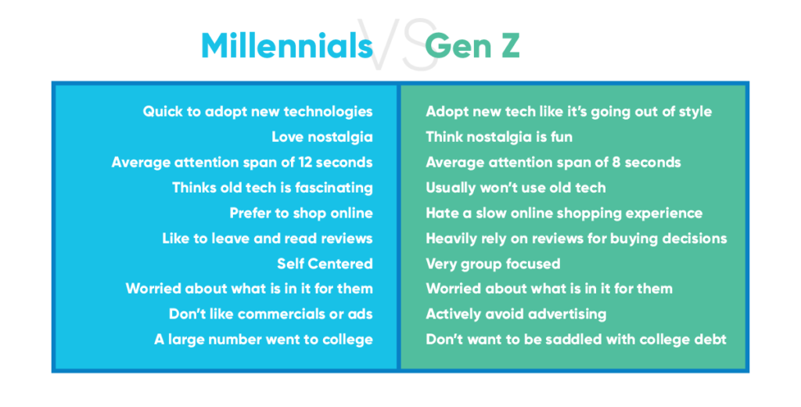

Rule #4 - They Want Information
Because they were born and raised in an era where internet access has always existed, Gen Z heavily researches products before they buy them. From Google to Wikipedia, they comb the internet and its seemingly endless stream of information and are constantly informing themselves on things that pique their interest. So when it comes to your brand, you need to have lots of informative content to engage and educate the Gen Z consumer about your product and its benefits.

Rule #5 - They Despise Gimmicks
To touch on an earlier point, traditional marketing efforts typically fall upon deaf ears when it comes to Gen Z. The flashing billboards with BUY NOW written all over it style approach is dying with each passing day as the media world evolves. The campy, mascot driven campaigns of yesteryear are frankly frowned upon by this new generation. They simply do not respond to this advertising angle. The days of brands hitching their wagons to characters like Ronald McDonald are beginning to come to an end. Gen Z can smell an ad from a mile away like a bloodhound with a fresh scent. Avoid gimmicks if you hope to garner the attention of Gen Z'ers, because generally speaking, gimmicks are a turn-off for them.

Rule #6 - You Have To Meet Them Where They Live
Being that the very youngest of this generation was born in 1998, it's no surprise that Gen Z is the most tech-savvy generation of them all. They spend exorbitant amounts of time online and on social media. So it makes sense for your selling strategies to be optimized for social and mobile, first and foremost. This includes multiple touchpoints with direct, CTA based messaging that utilizes various formats (video, stories, static image posts, etc.). As mentioned above in rule #5, sales gimmicks of the past don't work in this modern social media ecosystem. Your messaging should be more human, and designed to produce engagement from the audience. So focus on direct, individualized messaging and content.

Rule #7 - You Must Use A Mobile-First Strategy
Our final rule on the list is an expansion upon an element of rule #6; a mobile-first strategy. When it comes to Generation Z and millennial consumers, your brand needs to clearly articulate their products and services through a mobile-first strategy, most ideally through high-quality video content.

Best Practices For Marketing to Gen Z
Here are some quick tips on ways to directly market to Gen Z, and ways to reach this growing demographic.
Utilize Social media ads and influencer marketing
If you can build a creative ad that pops up in their social media feeds and captures their attention in a split second, you might secure a few purchases. Influencer marketing allows you to utilize a public figure on social media to prove your product’s worth to thousands of followers, and potential to achieve incredible ROI.
Focus On The Customer Experience
Marketers are behind the curve if they still subscribe to the notion of 'selling' in the traditional sense. In today's world, it's all about persuasion, not product-pitching. The marketing realm has pumped the brakes on the played out "limited time offer" style approaches, along with other tried-and-not-so-true marketing campaign tactics. Instead, they are beginning to market to Generation Z by providing quality customer service and enhanced customer experiences.

READY TO GET STARTED WITH INFLUENCER MARKETING?

