Out of Stock Online? Zara Hopes Shipping From Stores Will Boost Sales

The fast-fashion behemoth is using its downtown stores to ship online orders, aiming to minimize sale hurdles and speed up delivery
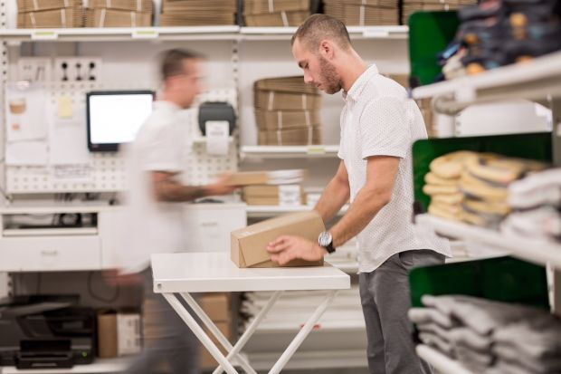
The ship-from-store operation inside a Zara store in Spain. PHOTO: ZARA
9 COMMENTS
By
Jeannette Neumann
July 31, 2018 7:00 a.m. ET
MADRID—Fast-fashion giant Zara is equipping its stores to also ship online purchases, betting that the move will boost sales of full-priced items that can be delivered to customers more quickly than from a warehouse.
The rollout encompasses around 2,000 stores in 48 countries, including the U.S., making it one of the largest-scale attempts by an apparel company to repurpose downtown shops to help fulfill online orders. Executives at Zara, whose Spanish parent company Industria de Diseño Textil SA ITX +0.11% is the world’s largest fashion retailer by sales, say they expect to complete the transformation by year’s end.
“This is something very, very strategic for us, this idea of full integration between store and online stockrooms,” Inditex Chairman and Chief Executive Pablo Isla told analysts in June. The ability to offer a shopper what she wants, and quickly, increases the likelihood of a full-price sale, Mr. Isla said.
For instance, a Zara blazer could be out of stock online but available at a store near where the online shopper lives. With the new ship-from-store option, that store could then mail the blazer to the online shopper’s address.
Zara’s efforts are part of a broader push among retail executives in the U.S. and Europe to rethink how they can better use their network of brick-and-mortar stores to compete withAmazon.com Inc., whose dominance in the retail industry has depressed profits and set new standards for speed of delivery. While some investors have considered traditional retailers’ vast store networks costly and antiquated, industry executives are increasingly equipping them to fulfill online orders to quicken delivery times, cut delivery costs and lift sales.
“There has been a trend lately to think of a store as a liability,” Forrester Research Inc. principal analyst Brendan Witcher said. “It’s an asset—but you need to learn to use it correctly.” Mr. Witcher expects about one in three U.S. retailers with annual sales of more than $1 billion to have ship-from-store in place by 2020, up from nearly zero five years ago.
Traditionally, retailers shipped items from warehouses to downtown locations. As online shopping grew, many retailers created inventory lines specifically for internet orders. Retail companies including Zara have been working to merge their inventory for online and in-store purchases rather than keeping separate stocks, to minimize lost and discounted sales.
Ship-from-store initiatives are one pillar of efforts by Zara and other retailers to tackle the far bigger problem of mismanaged inventory, which, by one estimate, cost retailers nearly $1.4 trillion in lost sales in 2017. Retailers world-wide, from big-box stores to fashion brands, lost an estimated $686 billion in sales last year because items were out of stock, according to a June report by research and advisory firm IHL Group. The firm estimates that retailers lost another $675 billion last year because of overstock, which triggers markdowns.
Zara executives told analysts in June that shipping out from their stores has had a negligible impact on overall costs in Spain and other countries where they have already rolled out the program.
While shipping online orders from downtown stores can lower delivery costs, some retailers have struggled to make ship-from-store profitable because they lack the technology to track in-store and in-warehouse inventory accurately. Logistics are also a challenge, particularly for big-box retailers that have varied merchandise ranging from 50-pound bags of dog food to electronics.
Gap Inc. launched ship-from-store in late 2012 and has continued to outfit additional stores and brands. J.C. Penney Co. started shipping from 250 stores in 2016 and rolled it out to its remaining 610 U.S. and Puerto Rican stores last year. While Inditex is behind some of its U.S. peers in adapting its store stockrooms to fulfill online orders, Zara’s parent company is the first major European apparel company to roll out ship-from-store, analysts say.
Executives at Berlin-based Zalando SE , Western Europe’s top online apparel-and-footwear company, said they receive about 40 million notifications each year that a shopper wants to buy an item that is currently out of stock on their website. To cut that figure, Zalando is working with around 30 partner brands in Germany to connect their in-store inventory to Zalando’s website, enabling shipment of online orders from those stores.
The integration has sped up some delivery times, says Carsten Keller, a Zalando vice president. In 2016, Zalando delivered an Adidas item, which was ordered on zalando.de, from an Adidas AG retail store in downtown Berlin to the shopper’s home in 26 minutes—its fastest delivery time.
“Warehouses on the outskirts of cities will never be as close to consumers as stores are,” Mr. Keller said.
Write to Jeannette Neumann at jeannette.neumann@wsj.com

