For Macy’s, a Makeover on 34th Street
By NATASHA SINGERNOV. 1, 2014
Inside
Continue reading the main story Video
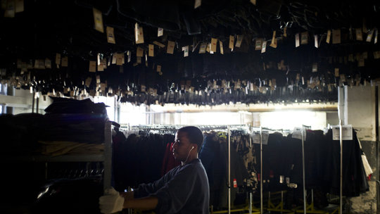

Play Video|2:52
Terry J. Lundgren, the chief executive of Macy’s, strode through the women’s shoe department of the company’s flagship store in Manhattan’s Herald Square, determined to find a bargain.
With the lean build of an athlete and the immaculately coifed gray hair of a television anchor, Mr. Lundgren cased the floor and dashed over to a display table of classic shoes, aimed at women in office jobs.
“Look at this great-looking boot for $69!” he exclaimed, holding out an unadorned black boot with a low heel.
Briskly, he made his way to the area dedicated to mainstream designer shoes.
“You can see the price points elevate as we go,” he said, stopping at the store’s Coach department to point out a black leather boot with a gold buckle. “You can get a low boot at Coach for $229,” he said, reading the price tag.
A mischievous expression came over his face as he stepped into Macy’s in-store Gucci shop.
“Let’s do another low boot here,” Mr. Lundgren said, holding aloft one made of buttery black leather and decorated with Gucci’s signature gold bit. “This one would be $995. This would be your escalation.”
Continue reading the main story
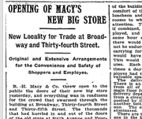
OPEN Document

Document: Macy’s Opens on 34th Street

Macy’s Herald Square occupies a singular place in American retailing. Established more than a century ago, the store now encompasses nearly an entire city block. The extensive real estate has always been central to its mission: offering a vast array of goods at prices so varied that everyone can afford to buy something. Even today, to keep price-conscious customers coming back, the store often runs clearance-sale ads with coupons in Sunday newspapers.
But now Macy’s is revamping the look, product mix and infrastructure of its flagship store to better cultivate less price-conscious shoppers with greater profit potential. One sought-after group is big-spending foreign tourists looking for prestige brands like Gucci. Another target audience is millennials — people born between roughly 1980 and 2000.
The reframing of the Herald Square store’s mission is part of a corporate strategy, known internally as “My Macy’s,” to tailor the product assortment at each of the 789 Macy’s stores nationwide to the needs and wants of local customers. In practical terms, that means the Herald Square store stocks more smaller-size slim-fitting suits than, say, a Macy’s store in Minneapolis, to accommodate a large contingent of Asian tourists. The flagship also carries a much wider array than regional Macy’s stores of Ralph Lauren Polo, Tommy Hilfiger and Michael Kors — the kind of classic American clothes that customers from abroad like to take home. For the huge numbers of shoppers who commute to Manhattan for work, the store also stocks a wider variety of black leather tote bags than stores elsewhere.
The hyperlocalization comes as Macy’s tries to differentiate itself not only from other traditional department stores but also from e-tailers like Amazon. Coupled with other strategies, like enabling customers to order products online for in-store pickup, the local approach seems to be paying off. In the 2013 fiscal year, revenue at the company grew to $27.9 billion, compared with $23.5 billion in 2009.
Continue reading the main story
Still, it is one thing for managers to modify products at regional Macy’s stores and quite another to pivot an enterprise as mammoth as Macy’s Herald Square.
At around 2.2 million square feet, including stockrooms and offices, it is one of the largest stores in the world. It generates about $1 billion in annual sales, according to estimates from industry analysts. (The company does not release sales for individual stores, but Mr. Lundgren said he did not dispute the estimate.) Even in an on-demand culture where people are inclined to shop online, the store draws about 20 million visitors a year.
Continue reading the main story Slide Show
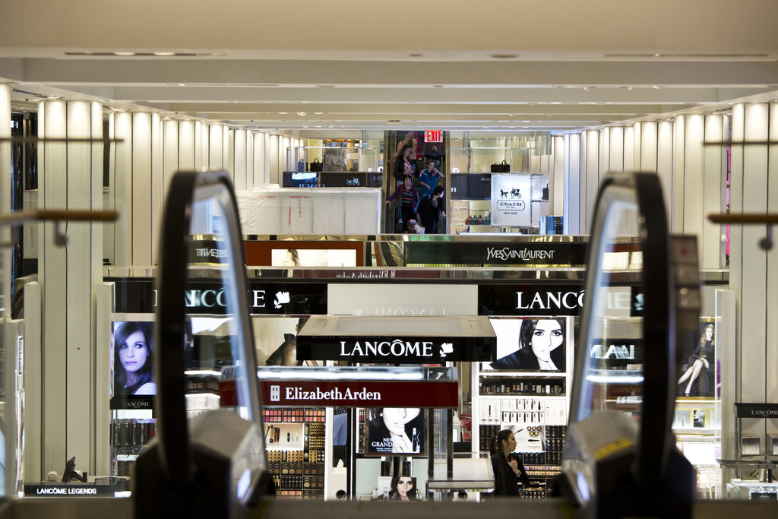
To elevate that bricks-and-mortar experience, executives are remaking the store in a fittingly gargantuan way — with a four-year, $400 million overhaul. By the time the renovation is completed next year, the store will have gained an additional 100,000 square feet of selling space.
“I’ll make this claim,” Mr. Lundgren said. “There has never been a store in the world that has ever had a $400 million renovation over four years.”
One of the showpieces of the makeover is the women’s shoe department, an acre of retailing that reflects the rebranding of Macy’s Herald Square as an upscale global shopping destination. Although a few sections at the back of the department sell midpriced shoes, much of the floor now spotlights higher-end merchandise.
Standing in front of the Macy’s in-store Louis Vuitton shop, Mr. Lundgren couldn’t resist doing another price check. He glided across the plush champagne carpeting and picked up a black pebbled-leather boot.
“That would be $1,160. It’s simply $1,100 more than the first boot we looked at,” Mr. Lundgren said. “We have to have a broad appeal to a diverse group of individuals to be the size that we are.”
Lost in the Aisles
Photo
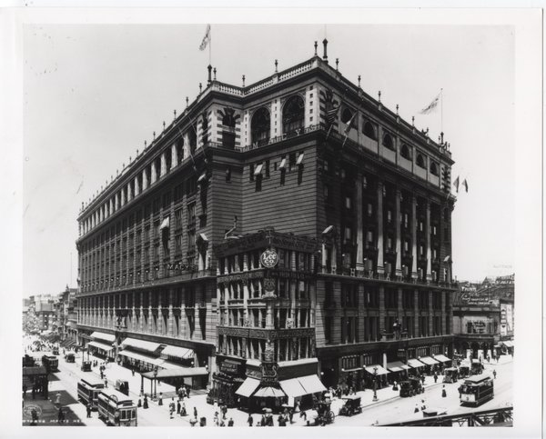
The Macy's building in 1903. Credit Macy's
When Macy’s Herald Square opened in 1902 — having outgrown its downtown location — the ornate brick-and-limestone building facing Broadway occupied about half of a city block. Its earliest proprietors envisioned price-sensitive customers seeking quality merchandise. To announce the opening, they ran an ad with the slogan: “We Sell Cheaper Than Any Other House.”
That price-conscious strategy would be a company mainstay, whether on the store’s opening day, when it sold goods like muslin underwear, or during World War II, when it sold live baby chickens to encourage domestic food production.
Over time, the store expanded. In the 1920s and 1930s, the company built a huge addition on Seventh Avenue. Piecemeal additions and alterations over the years made the place increasingly hard to navigate. Walled-in escalators prevented visitors from seeing which departments would greet them at the end of the ride. So many clothing racks, and so few aisles, forced shoppers to zigzag to cross the store. The layout was the opposite of intuitive.
“In the old days, you wanted people to get lost in the store because, if they get lost in the store, they would stay longer and spend more,” said Marshal Cohen, the chief industry analyst at the NPD Group, a market research firm. “That’s how department stores were built”
In 2010, Macy’s hired a firm specializing in pedestrian traffic to study shoppers’ perambulations. The researchers concluded that 30 percent of visitors to the store were visibly lost.
Company executives initially decided to invest $55 million over 18 months to modernize the store layout. But Mr. Lundgren had more ambitious ideas.
Because of its location a block from the Empire State Building, the store attracts roughly six million tourists a year, several million of them from outside the United States. Mr. Lundgren wanted to attract more, especially shoppers from Brazil, China and other emerging-market nations with growing middle and upper classes hungry for luxury logos.
“We have this international business,” Mr. Lundgren recalled thinking. “It was only going to grow.”
To entice those customers, he decided, Macy’s Herald Square would have to best not just other American retailers but also leading retailers around the globe.
So he embarked upon a world tour to check out the goods and furnishings at international competitors. He visited Harrods, Selfridges and Harvey Nichols in London; Isetan and Takashimaya in Tokyo; Galeries Lafayette in Paris; and El Corte Inglés in Madrid.
“Then we came back and said, ‘We’ve seen the standard,’ ” he said. “How do we go beyond that and create the next places that retailers are going to want to emulate?”
He concluded that it would need an extreme makeover. “I certainly hope I don’t have to spend another $400 million in a decade,” he said. “But to do the transformation required a major overhaul.”
Mr. Lundgren personally started calling the chief executives of international luxury brands with whom he was friendly, asking each to install their own shops as anchors on a soon-to-be revamped Macy’s main floor. First, Louis Vuitton agreed to build a three-floor, in-store concession, Mr. Lundgren recounted. Then Burberry signed on to do the same, followed by Gucci.
But customers for that kind of high-priced merchandise wouldn’t be content to rest their well-heeled feet at the McDonald’s on Macy’s children’s floor or at the tiny Starbucks counter near the linen department. So the company installed the Herald Square Cafe, operated by Starbucks. It serves Starbucks Reserve, an upscale coffee line, and brews individual cups for each customer.
Standing in the women’s shoe department in a three-piece gray suit, Mr. Lundgren pointed out the amenities that Macy’s has added to entice exacting world travelers. To his left, the gleaming facade of Gucci faced a spacious Burberry boutique to his right. In between, young women with shopping bags at their feet were parked on banquettes at the cafe.
“It’s more of a European style for you to relax in during the day,” Mr. Lundgren said, noting that the cafe also served wine and Moët & Chandon Champagne. “We thought it would be the perfect way to rest and replenish before you go back out to the floor again and, hopefully, buy more shoes.”
Continue reading the main story
The heightened focus on trendier and costlier goods may be a business necessity. In 2018, Nordstrom and Neiman Marcus, rivals of Macy’s, each plan to open their first stores in Manhattan.
“What Macy’s is trying to do with the renovation is elevate itself further, to get away from the J. C. Penney across the street,” said Mr. Cohen, the industry analyst. “This is their way of making sure that people know that they are in the luxury game and establishing their foothold early on.”
The reconstruction project will continue through next year. But some visitors are already registering the rebranding of Macy’s flagship.
Photo
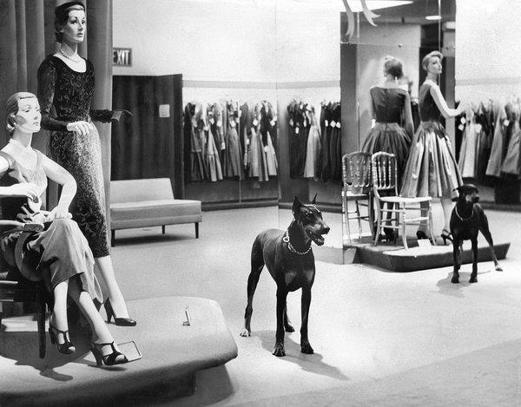
In 1955, a team four of Doberman pinschers guarded Macy's Herald Square store after hours. Two of them, Red Star and Mom, patrolled the women's dress department. Credit Larry C. Morris/The New York Times
“I would not want to shop at the Macy’s I remember,” said Peter Horvath, a retail consultant at the Institute of Brand Logic in Innsbruck, Austria. He recalled the Macy’s of yore as an uninviting, crowded souk of a shop with dim lights, worn carpets and middling merchandise. On a visit to Manhattan in October, he said he was surprised to find the store now possessed of grand halls, modern merchandising and natural light. “It was just a better feeling than before,” he said.
The renovation started in 2012 with the unveiling of a revamped grand hall on the main floor and a new women’s shoe department. Last year, an Italian restaurant was introduced on the sixth floor. This weekend, new departments for men’s tailored clothing and women’s casual sportswear are to open. Still, the impeccable presentation of the floors downstairs can make certain yet-to-be-renovated sections upstairs, where locals buy staples like linens, feel a bit neglected. “I think it’s temporary growing pains,” said Liz Dunn, the chief executive of Talmage Advisors, a brand consulting firm in Manhattan. “Macy’s upper-floor experience needs to be more flawless.”
A District Unto Itself
This fall, Macy’s Herald Square will process 15 million pieces of merchandise. To accommodate the holiday shopping surge, its staff will temporarily increase to 6,500 employees from its usual 4,400. And more than 200,000 people are expected to come by to visit Santa Claus.
Macy’s Inc. manages its regional operations by dividing its department stores into 60 districts of 10 to 12 stores. But the flagship store is so large that it is considered a district unto itself, with a management team of 350 executives, said Patti M. Lee, the district vice president and general manager of Macy’s Herald Square.
“One of the questions you have with an operation of this size and velocity is: How do the goods get in here and out to the floor?” she said. “What goes where? It’s a big jigsaw puzzle.”
Consider the logistics of getting just one pair of Michael Kors moccasins into the store and out to a customer. The revamped women’s shoe department occupies 63,000 square feet on the second floor, including stockrooms. That is several thousand square feet larger than a football field.
Goods destined for Herald Square first arrive by truck at Macy’s Logistics and Operations Center in Secaucus, N.J. It’s a hangar-size building that also processes products for regional stores in New York, New Jersey and Pennsylvania. Large cartons of, say, shoes or peacoats, are tagged with bar codes and sent along overhead conveyor belts that loop around like highway overpasses. Then the machinery shunts the cartons down aisles, called “sorts.” Other Macy’s stores need one sort for all of their merchandise, but Herald Square requires 18 — with one sort dedicated just to women’s shoes.
Continue reading the main story
The flagship store also has a specialized fleet of small trucks. Because the store’s loading bays were built so long ago, standard-size trailers don’t fit.
At the store, employees transfer the deliveries onto freight elevators and take them to a processing center on the 10th floor, above all the shopping floors. There, a round-the-clock staff unpacks everything, then the items are shuttled to retail areas on lower floors.
It’s labor intensive. During the holiday season, it can take 1,800 employees a total of 35,000 hours to process a week’s worth of deliveries. Goods that arrive on Thursday evening may not reach the selling floor until Saturday morning.
“There’s no machine that can do it,” Ms. Lee said. “You have to unpack it.”
As part of the store upgrade, however, Macy’s wanted to speed certain profitable fashion accessories, like shoes, to customers impatient to buy them.
“Our biggest challenge was: How are we going to get the shoes to the customer without the associate disappearing for a long time?” Ms. Lee said.
To solve that problem, sales associates in the men’s and women’s shoe departments have each been outfitted with an iPod Touch; on it, they track products using a radio-frequency tag identification system. When a customer wants to try on, say, a pair of Michael Kors black leather Daisy Moccasins in size 8 1/2, a sales associate on the floor scans the tag of the display model. Instantly, the iPod Touch screen displays the available colors and sizes.
Next, the order is routed to runners, called “shoe expediters,” who work in adjacent stockrooms. They carry personal digital assistants that direct them to the exact aisle and shelf where that pair of shoes is stored. Their assignment is to find that one shoe box — amid as many as 250,000 pairs of shoes stocked in the store — and bring it to the waiting customer in two minutes or less. That’s much faster than the previous, low-tech system.
Executives hope that the new technology-enhanced customer service will impress at least some digitally savvy world travelers. Ideally, it may also inspire some couch potatoes, accustomed to ordering their footwear from Zappos.com, to come into the store.
“They can’t get that at home,” Ms. Lee said.
Tweets and Tailored Suits
Photo
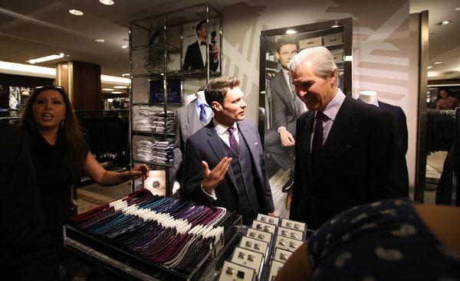
Ryan Seacrest, whose line of men’s suits is sold in the store, talked with Terry J. Lundgren, the chief executive of Macy’s. Credit Ozier Muhammad/The New York Times
Ryan Seacrest doesn’t usually act as window dressing.
But one morning in early September, Mr. Seacrest, the host of “American Idol,” broadcast his daily radio show live from a makeshift studio in a window of Macy’s Herald Square.
He was appearing at the store to promote his new line of men’s suits and matching accessories, called Ryan Seacrest Distinction.
It was a photo op engineered to go viral. Hundreds of fans had gathered outside the window to gawk. Mr. Seacrest, wearing a gray suit from his own line, took a selfie with fans in the background and posted the photo on Twitter, where he has 12.9 million followers.
At the edge of the crowd, a Macy’s executive anxiously asked her colleagues, “Has someone from our social media team come down yet?” Although Macy’s Twitter account has 637,000 followers, it has aimed more at young women and moms than at 20-something men.
Store executives are making a concerted effort to woo younger customers. By working with upstart midpriced brands like Mr. Seacrest’s, executives hope to increase the store’s credibility with shoppers who don’t take their fashion cues from traditional media outlets. Executives say the store has repeatedly sold out of the Seacrest line’s tuxedos, which young men have been buying for bridal parties.
Still, it will be challenging for the store to win over new clients, like fickle millennial consumers. And consider another group: wealthy, fashion-conscious Manhattanites. They tend to avoid Macy’s Herald Square the same way that Parisians snub the Eiffel Tower.
“There are a lot of challenges to attracting new visitors,” said Ms. Dunn, the retail consultant. “Macy’s has the opportunity to overcome the impression that it’s maybe a place for tourists or it may be a little bit downmarket.”
As a special guest that morning, Mr. Seacrest had invited Nick Jonas, the pop singer, who had a new album. As they sat in Macy’s window chatting on the air, Mr. Seacrest prodded the singer to strip off the white T-shirt he was wearing and try on a checked dress shirt from the Seacrest line. The crowd on the other side of the window whooped.
Standing on the sidewalk, Justine Babuschak, a student at Montclair State University in New Jersey, who had traveled to Manhattan to see the broadcast, was enjoying the window display.
“Nick Jonas was the real reason I came here,” Ms. Babuschak said. She was trying to decide, she said, whether to go into the store to check out the junior dresses.
A Window on the World
Photo
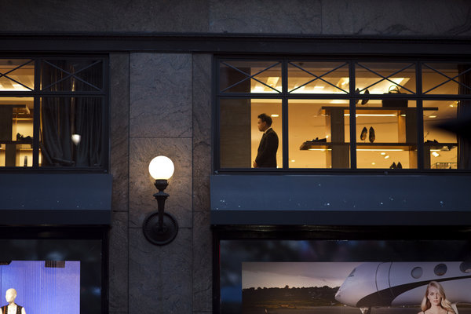
Before the renovation, many windows were covered up, and the store lacked natural light. The overhaul has changed the look, product mix and infrastructure of the flagship store. Credit Todd Heisler/The New York Times
Until earlier this year, a large stockroom with opaque windows occupied the front of the fourth floor on the Broadway side of the store. This weekend, however, that 8,000-square-foot space is to become a Tommy Hilfiger retail zone, with six bay windows and views of the Empire State Building. Some of the items, designed for sale in Europe, are exclusive to Macy’s Herald Square in the United States.
Mr. Lundgren says the Hilfiger brand and other vendors see the store not just as a sales venue, but also as a marketing opportunity to expand their international audience.
Macy’s flagship store, for instance, has long been the top seller worldwide for Clinique, a midpriced cosmetics brand. To coincide with the renovation, however, the Estée Lauder Companies, the parent company of Clinique, also introduced counters for its prestige brands: La Mer, a luxury skin-care line, and Tom Ford Beauty, fragrances and cosmetics.
Continue reading the main story Write A Comment
“This unique destination offers the right luxury experience and the energy that consumers are looking for, especially tourists,” said Fabrizio Freda, the chief executive of the Estée Lauder Companies.
In a sense, Macy’s Herald Square is simply following its own precedent: tailoring its merchandise to reflect the needs and aspirations of the customer of the moment. “We used to sell chickens,” said Ms. Lee, the store’s general manager. “There used to be a butcher shop. We’ve sold camping equipment. We sold pianos. We’ve sold Model-T Fords.”
One thing hasn’t changed: whoever the customers, they can still ride the store’s historic, clanking wooden escalators.
A version of this article appears in print on November 2, 2014, on page BU1 of the New York edition with the headline: Makeover on 34th Street. Order Reprints|Today's Paper|Subscribe

