Card Issuers Jump Onto Apple Pay Bandwagon

Latest Product Launches Stir Hopes for Fewer Cash Transactions

By
Robin Sidel

connect

Sept. 12, 2014 1:21 p.m. ET
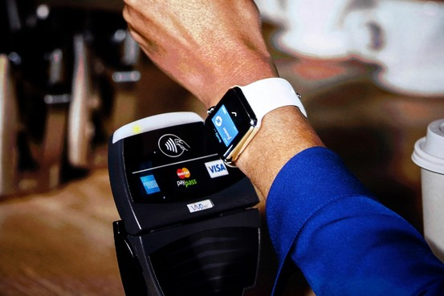
Apple's iPhone6 and smartwatch promise consumers a more secure way to make card payments Reuters
Apple Inc.'s latest product launches are fueling hopes in the credit-card industry that consumers will move further away from cash as they embrace technology that lets them pay for purchases with electronic gadgets.
The Apple iPhone6 and Apple Watch promise consumers a more secure way to make card payments at checkout registers. It also is expected to make credit-card and debit-card transactions faster and easier for shoppers at bricks-and-mortar stores and when making online purchases.
That, said industry executives, should lead to more payments taking place over electronic networks, and fewer cash transactions.
"If paying by phone is easier for the consumer, it is first and foremost likely to displace cash," said Jud Linville, who runs Citigroup Inc. 's credit-card business.
Card issuers will pay Apple a small per-transaction fee to participate in Apple Pay, which means they would make less money than they would with a regular swipe at the cash register, according to people familiar with the arrangement. The companies are betting that they will more than make up that cost as the volume of electronic payments increases, these people said.
But the credit-card industry has jumped on technologies that have fizzled in the past. What's more, the Apple gadgets will work only in stores where merchants have upgraded their equipment to accept the technology.
While credit and debit cards represent more than half of the purchases made for retail goods and services in the U.S., cash continues to dominate in small transactions. A recent consumer survey conducted by the Federal Reserve found that cash represented 66% of transactions under $10 and 58% of transactions under $25. When the transaction was more than $50, cash was used in less than 20% of the payments.
The idea of paying for small purchases with a phone may be a tough sell for people like iPhone user Alfred J. Zera who aren't ready to give up a stash of cash.
Mr. Zera, a 36-year-old plumber from New York City, is looking forward to upgrading to the new iPhone and thinks he would likely use the payment feature instead of his credit card. But when it comes to small items, "I'm a big cash guy," he said.
Apple Pay, announced this week, will support credit and debit cards that are processed on the Visa Inc., MasterCard Inc. and American Express Co. networks. Nearly a dozen of the biggest card issuers have signed onto the payment technology, representing 83% of the credit-card purchase volume in the U.S., according to Apple.
The payment mechanism uses a technology called near-field communication that lets consumers tap their phones at checkout terminals instead of swiping a credit card. The card companies are hoping the convenience of paying with devices already in consumers' hands will spur more electronic payments for small purchases.
"The ability to be able to tap [the phone] and go will make it easier than fumbling through your pockets for change or digging for crumpled bills at the bottom of your purse," said Chris McWilton, president of North America operations at MasterCard.
That is why the biggest U.S. card issuers are willing to pay transaction fees to be included in Apple Pay. Issuers that are signing on include J.P. Morgan Chase & Co., Bank of America Corp. BAC +1.33% Bank of America Corp. , American Express, Citigroup Inc., Capital One Financial Corp and Wells Fargo

More on Apple Pay
- Can Apple Sell Consumers on Payment on Your Wrist?
- Why Tap-to-Pay Beats Credit Cards
- Will Stores Warm Up to Apple Pay?
- Can Apple Solve Riddle of Mobile Payments?
- Apple Boss Makes His Boldest Bets Yet
"If it's easy and fast, that's a win for the customer and for us," said Tom O'Brien, general manager of mobile payments for the credit-card business of J.P. Morgan Chase, the nation's largest card issuer.
The ease and speed are appealing to Jacaria Moore, a 36-year-old teacher and part-time bartender who said she would use Apple Pay to replace her credit card as well as cash.
"I have my phone with me all the time so I would definitely use it," said Ms. Moore, who lives in Jersey City, N.J.
Apple Pay is also securing the phone payments with a technology pitched by the credit-card industry that replaces customer information with a unique set of numbers, called a token, that is useless in the hands of criminals.
Barclaycard, Navy Federal Credit Union, PNC Financial Services Group Inc., USAA and U.S. Bancorp also will be included in Apple Pay.
The structure of Apple Pay shows that technology companies, once considered potential threats to the established card industry, instead are relying on the existing infrastructure rather than creating a new one of their own.
"Apple has taken pieces of the payments ecosystem that exist today, combined it with their technology and their customer base, and pulled it together into a unique payments experience for their customers," said Mr. McWilton.
As a result, Visa and MasterCard are spending significant efforts on establishing relationships with companies that are bursting into the payments industry.
"We want to allow innovators to access our network and create an environment where it's easier for them to do business with us," said Jim McCarthy, Visa's global head of innovation and strategic partnerships. The company has also invested in some of the new technology companies.
Write to Robin Sidel at robin.sidel@wsj.com
• Email
• Print
• 34 Comments
• Order Reprints
• Facebook
Share
327
• Twitter

