America's New Chauffeurs |​​NYT Now

Uber, Lyft and a Road Map for Reinventing the Ride
JULY 11, 2014
Neil Irwin

When the hail-by-smartphone car service Uber and its competitors make news, it is usually for something like the raucous protests against them by cabdrivers across Europe, or for bizarre incidents like the (now-former) Uber driver who reportedly took a passenger on a high-speed chase this week in Washington.
But the future of urban transportation is being shaped this summer not through these types of flashy developments, but with seemingly unrelated announcements involving economic concepts like demand elasticity and dynamic pricing, and the all-important (noneconomic) concept of fuzzy pink mustaches.
You might have to squint to see it, but the economics of how people get around is on the verge of big changes, and a battle is brewing over who will be America’s chauffeur and what company will get rich along the way.

America's New Chauffeurs: Uber's Travis Kalanick Explains His Pricing ExperimentJULY 11, 2014

The biggest development has been Uber’s announcement that it is slashing prices for its UberX service in dozens of markets in the United States and abroad. (UberX is the company’s cheaper, more entry-level transportation offering — think a Nissan Sentra driven by a moonlighting grad student rather than the Lincoln Town Car driven by a seasoned professional offered by the company’s Uber Black service.)
Photo
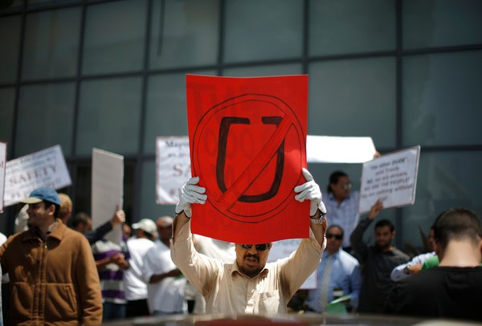
Drivers protested working conditions at Uber outside the company's office in Santa Monica, Calif., last month. Credit Lucy Nicholson/Reuters
The price cut amounts to 20 percent in New York and 25 percent in San Francisco and Los Angeles. By the company’s math, that leaves the price of a ride lower than that of a taxi in New York, and in other cities the price is now significantly lower. In some of those markets, it is even taking the entirety of the price cut out of its normal 20 percent commission.
What is Uber up to? What company cuts its prices voluntarily, particularly to the point where it ends up taking a loss on each transaction?
The key to understanding Uber’s strategy is the concept of “elasticity of demand,” which is how people will react to a lower price. If consumers’ demand is highly elastic, it means that a slightly lower price will lead to people taking a lot more UberX rides. That’s what the company is hoping happens — and, assuming it does, the lower prices could become permanent.
Continue reading the main story
Consider how this plays out in practice. The other day, I had to run a quick errand at home during the middle of the workday. There were various options: I could walk 20 minutes in the heat to get home; I could take a bus, which would have involved less sweat but the same time frame; or I could take a D.C. taxi, which would cost $8 or $9 depending on traffic and tip size.
Or, thanks to the recent price cut, I could take an UberX for what turned out to be a $5.74 ride. And unlike in many Washington taxis, the air-conditioning was already on when I got in the car and there was no issue of the credit card reader’s being broken, a common problem that results in the need for cash payment.
Essentially, Uber is betting that lower prices will induce people like me to use the service far more often — for the commute to and from work, to business meetings during the day, and so on. The more it can get people in the habit of routinely taking several rides a day, the more it would be self-fulfilling: People will plan their day around having easy, quick access to an inexpensive ride.
“The whole point of price cuts is to get UberX pricing below the cost of owning a car,” Uber’s chief executive, Travis Kalanick, told me. “Let’s say you take three or four trips a day on average. If we can get the price of UberX low enough, we can get to where it’s cheaper to take Uber than to own a car.”
The company’s strategy this summer is to cut prices temporarily and see how much demand increases, and use that information to decide pricing in the future. If the lower prices lead to enough extra usage of the service to make up for the lost revenue on each ride, it will become permanent. It has done this in the past, and usually found that the lower prices do generate enough extra ridership to justify themselves, particularly when a price cut moves the service from being slightly more expensive than a taxi to slightly less.
Even as it explores the question of how low prices can go on the low end, Uber is also wrestling with how high prices can go on the high end. It has come under fire for “surge pricing,” hiking prices to a multiple of the usual rate when demand exceeds supply.
This infuriates customers in the best of times, like New Year’s Eve. It raises legal questions in the worst of times, like during a blizzard or hurricane. The New York State attorney general, Eric Schneiderman, has assailed Uber for price gouging in those extreme times, arguing that charging people eight times the usual rate violates the same laws that stop gas stations from overcharging for gasoline or bottled water in the aftermath of a storm.
This week, they reached an agreement: Uber will cap its surge pricing during disasters at a level determined by the maximum prices over the previous 60 days. In other words, surge pricing is here to stay, but the company will not engage in any extraordinary price surges when disaster strikes. It has signaled that it will apply the same principles to its pricing approach nationally.
Also this week, we have new signs of how the landscape in this burgeoning industry might look. Lyft, a competitor of Uber, said it would begin service in Brooklyn and Queens, its first foray into New York. It is a reminder that beyond the traditional taxis that are Uber’s main foes in the regulatory arena, it is sure to face more competition. (But that battle will have to wait. On Friday, Mr. Schneiderman sued to block Lyft in New York, saying it was “in open defiance” of state and local licensing and insurance laws.)
One interesting development: Lyft seems to be inching away from some of its warm and fuzzy, friends-giving-a-ride-to-friends, Kumbaya elements, which both differentiate it from Uber and make it less primed to be used for the full range of trips, including business travel. Its New York cars will eschew the giant pink fuzzy mustaches normally placed on Lyft front grilles, as will a new high-end S.U.V. service it is experimenting with in San Francisco.
As much as fans of the service may like the quirky, communal aspects of Lyft, it is hard to imagine riding to a business meeting in a car with a giant pink mustache on it. (Free advice for Lyft: Eliminate the convention that riders get in the front seat and give their drivers fist-bumps as they begin a drive. A lot of your potential customers want to get to their lunch appointment on time, not make a new friend.)
People have tended to view Uber, along with its rivals, as a more high-tech competitor for existing taxi services, but this isn’t quite right. What they’re actually doing is trying to reinvent the way people get around. And the action around pricing and competition lately is giving a more concrete sense of what that looks like:
The market for rides will be cheaper, with more availability of cars, than it ever has been before, which should make it easier to use these services for routine transportation. Prices will spike fairly routinely when there is a great deal of demand, but with limitations on those price spikes during emergencies. And whether from Lyft, other new entrants like Sidecar, or even from traditional taxi companies improving their pricing to compete, it is clear that this is going to be a brutally competitive arena.
The Upshot provides news, analysis and graphics about politics, policy and everyday life. Follow us on Facebook and Twitter.

