Technology |​​NYT Now

$199 Apple iPhone 6 Is Fiction, if Not Fantasy
SEPT. 27, 2014
Inside
Photo
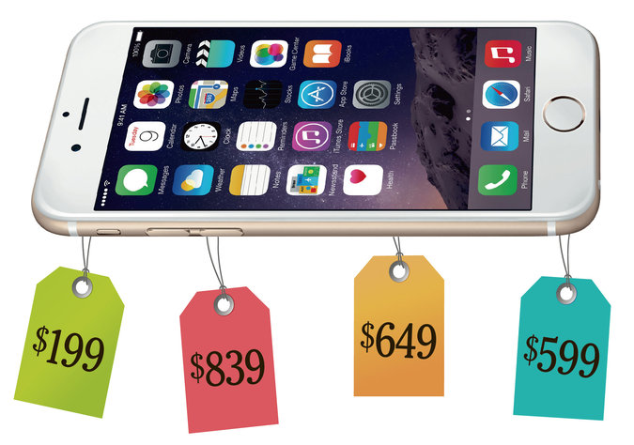
Credit Minh Uong/The New York Times
Strategies
By JEFF SOMMER
What does it cost to buy a basic new iPhone 6? If you think the answer is $199, and you’re happy believing that, you may want to stop reading now.
If, like me, you watched Apple’s self-referential love fest for the new iPhone and suddenly wanted one very badly, you may have been encouraged by the way the price was listed: “From $199.”
Apple could have been more transparent and said that the typical base price was $649 or more. But that would have spoiled the fun.
It turns out that upgrading an iPhone every two years on a 24-month phone service contract, as I’ve been doing, doesn’t cost $199. This year it will cost me at least $649. In fact, it could cost considerably more than that if you add the miscellaneous charges that your phone carrier may impose, and the discounts that it may withhold.
Keeping your costs under control may take some work: I discovered that a relatively new option — buying a phone on the installment plan from AT&T, my current carrier — turns out to be much cheaper for me than getting the phone through a service contract, the way I’d done it before. I didn’t know that until I crunched the numbers.
“I think it’s fair to say that people wouldn’t be as motivated to go out and buy if they thought it was a $650 purchase,” said Craig Moffett, senior analyst and a partner at MoffettNathanson Research. “And if you look at the marketing issues and the accounting issues, it’s fair to conclude that the companies have a strong incentive to obfuscate about pricing.”
The information you need to figure out the real price exists on the Apple website and on the sites of the various major phone carriers. But often it’s not easy to find the numbers or to calculate them. The first time I tried, on AT&T, I had to click through several steps of the online ordering process before I stumbled on the dismaying truth. (T-Mobile, which calls itself “America’s Un-carrier,” is commendably clearer.)
Mr. Moffett has been studying phone pricing for years, and he gave me a quick primer. The confusing pricing has major implications for phone company investors who may not understand that the newer purchase options enable the companies to claim higher revenue over the short term than they could with the older plans. That accounting change, he said, is masking a decline in phone company revenue. “There are a lot of unsophisticated consumers and investors who don’t understand all of this,” he said.
Here’s how it works.
Every two years, whenever there’s a full iPhone upgrade, as there is right now, there is typically a surge in people ordering new phones: Apple reported that people placed 10 million iPhone orders last weekend. But this year, there are more choices, and I found them confusing.
Mr. Moffett explained why: “This is the first iPhone cycle when what’s known in the industry as E.I.P. — or equipment installation plan — is really popular among the big carriers. They’re giving a lot of discounts. And you may be able to get a better deal that way right now, if you’re willing to look for one. Unfortunately, many Americans are allergic to math. And you may have to do the numbers yourself to find out which plan is better for you.”
I started buying an iPhone 6 on AT&T’s website the way I always have, with a standard two-year service contract. But this time, I was surprised to discover that if I continued down that road, AT&T would penalize me in two ways.
This part may be tedious if you’re not at least a little nerdy, but please bear with me:
First, AT&T said it would charge me a $40 “upgrade fee.” And then, as I went further, a warning popped up. It said that while I could pay $199, I would no longer be “eligible for the Mobile Share Value monthly discounts” of $15 or $25 a month. In my case, it’s $25 a month. That’s because I use a lot of data: I’m part of a family-sharing plan that gives us 10 gigabytes of data a month.
If I got a phone for $199, plus $40 for an upgrade fee, I’d “lose” — that is, have to pay — $25 a month for my service plan for two years, or $600. Add all of that up, and it comes to $839. If you use less data, you’d presumably “lose” $15 a month for two years, or $360. Using the same calculations, you’d end up paying $599.
And there’s more. Because even the smaller and cheaper of the two main versions of the iPhone 6 dwarfs the iPhone 5 that I carry in my pocket, the protective case I’ve got now won’t fit on a new phone. And I won’t risk dropping such a precious gadget without a case. With a corporate discount, the cheapest replacement case I was able to find on the AT&T store goes for $16. Ouch. Tack that onto the final price.
That’s for a basic iPhone 6. Apple, you’ll recall, says the phone costs “from $199.” Hmm.
I found an excellent article on ZDNet by Ed Bott, who did this sort of calculation for a variety of plans and carriers. He concluded this way: “You know what? You can’t get an iPhone 6 for $199. And anyone who tries to tell you otherwise needs to go back to smartphone school.” I went back to smartphone school, with the help of Mr. Moffett.
I found that if I bought the iPhone from AT&T and qualified as a good credit risk, I would receive a 0 percent loan for the full cost of the phone and could pay it off over 24 months at $27.05 a month, which comes to a little more than $649. Let’s round that off at $650. There’s no $40 upgrade fee. And there’s no $199 down payment. (I would have to pay sales tax on the $649 cost of the phone.) For me, I concluded, it would be cheaper to buy the phone from AT&T on the installment plan. If I used less data, it would be cheaper to buy the phone from AT&T through a service contract. And, of course, there are different deals on different carriers.
Once I started down this road, it made me pause. Do I really need to replace my phone every two years if it’s going to cost $650?
As Farhad Manjoo has explained in these pages, many people don’t need to buy new phones that often. In my case, if I keep my old phone a bit longer, I’ll save $25 every month, and that adds up.
The installment plans are popular now, but they could hurt Apple and the phone companies, because they may wean many of us off the two-year upgrade cycle, Mr. Moffett said. “The E.I.P. plans are clearly better for one category of person — someone who will keep a phone for more than two years. They’re much cheaper.” And more of us might join that category, if we understand the numbers.
But through the magic of corporate accounting, the plans help make the carriers’ revenues look more appetizing. If you buy a $650 phone on the installment plan from a phone company, it counts as $650 in immediate earnings for that company even though the money actually comes in over two years. As these plans have become more popular, they’ve had a significant effect on the industry. Thanks to installment plans, annualized revenue in the second quarter for the entire American phone industry appeared to rise by 3.7 percent, Mr. Moffett calculated. When you exclude them, the industry would be declining in revenue for the same period by 2.1 percent, annualized.
For investors, that means the cellphone business may not be as attractive as it looks at first glance. And for consumers, it means that you’ve got to pay very close attention to the fine print when you get a phone. It’s actually cheaper — in some cases but not all — to buy a phone rather than get a subsidized phone on a two-year contract. It’s all in the details. Once you start examining the cost of a new iPhone, it may not look quite so irresistible.
A version of this article appears in print on September 28, 2014, on page BU6 of the New York edition with the headline: $199 Apple iPhone 6 Is Fiction, if Not Fantasy. Order Reprints|Today's Paper|Subscribe

