Snapchat: How Brands Reach Millennials

A year after opening itself up for business, messaging app shows its marketing potential
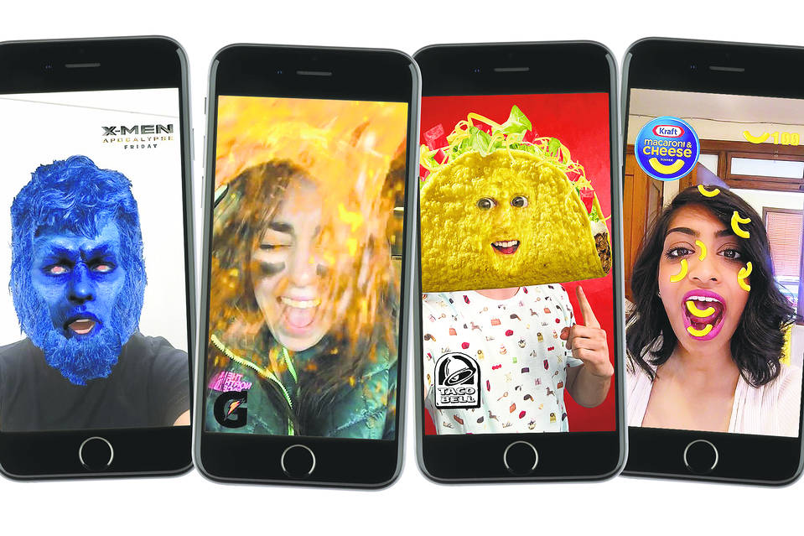
Sponsored lenses let brands pay to allow Snapchat users to superimpose products or characters on their photos. Above, filters for X-Men, Gatorade, Taco Bell and Kraft. Photo: PHOTO ILLUSTRATION/THE WALL STREET JOURNAL
By
Steven Perlberg

June 22, 2016 12:01 a.m. ET
Marisa Thalberg, chief marketing officer at Taco Bell, was fielding Cinco de Mayo-related pitches from her social media team when one idea stopped her in her tracks: a “sponsored lens” on Snapchat that would make people’s heads transform into a giant taco drizzled with spicy Diablo sauce.
“I don’t usually feel my age on these things. On this one, I was like, ‘I don’t know,’” said Ms. Thalberg, who is 47 years old. Taco Bell ultimately went through with the strategy, and the lens was a huge hit, garnering 224 million views on Snapchat, the disappearing-messages app that has become a fixture on the phones of the young consumers marketers are desperate to reach.

THE AD REVOLUTION
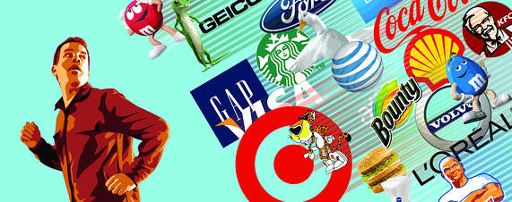
- Advertisers Try New Tactics to Break Through to Consumers
- Big Media Needs to Embrace Digital Shift—Not Fight It
- Snapchat: How Brands Reach Millennials
- Messaging Apps Line and WeChat Strike Advertising Gold
- Vice, BuzzFeed Tread on Madison Avenue’s Turf
- French Ad-Tech Pioneer Criteo Bucks Industry’s Gloomy Trend
- Creative Ad Agencies Shake Up Legacy Model
- Susan Credle: Advertisers Need to Be Storytellers
“I think it’s important that sometimes I feel uncomfortable,” Ms. Thalberg said. “On this one I’m really glad I trusted the instincts of the team.”
It has been a year since Snapchat Chief Executive Evan Spiegel took the stage at the Cannes advertising festival to announce to eager marketers that the app was essentially open for business, and some big brands, ranging from Taco Bell to Nike Inc. NKE 0.02 % to General Electric Co. GE -0.24 % , have been testing the waters.
But Snapchat, which was recently valued at nearly $18 billion, enters a mobile advertising business dominated by two tech giants: Facebook Inc. FB -0.28 % and Alphabet Inc. GOOGL 0.19 % ’s Google, which glean a massive amount of consumer data and have huge reach on mobile devices.
The duo makes up roughly half of the global mobile ad market, according to eMarketer.
“When you look at the $70 billion bleeding carcass of TV advertising, everyone wants a piece of that,” said Scott Galloway, founder of research firm L2. Platforms like Facebook, YouTube and now Snapchat are vying for shifting advertising dollars from TV to digital video, he said.
Taco Bell, a unit of Yum! Brands Inc., found that users spent an average of 24 seconds playing around with its lens during the daylong campaign. But the return on investment remains unclear.
“Can I tell you what kind of sales lift I got off that lens? No,” Ms. Thalberg said. “But I wasn’t looking at it that way. That was about creating a special moment for us on Cinco de Mayo.”
She declined to disclose what Taco Bell paid Snapchat for the campaign.
Snapchat offers a prime way to reach coveted “millennial” consumers on their home turf, with the app boasting 100 million daily active users. According to a Nielsen study commissioned by the company, Snapchat reaches 41% of all 18- to 34-year-olds in the U.S. daily.
Advertisers can place 10-second vertical video ads within the app’s Live Stories, which are collections of curated “Snaps” taken by users at events like sports games or award shows.
Or ads can be placed in stories on Snapchat Discover, where a couple dozen media companies like ESPN, BuzzFeed and The Wall Street Journal have channels.
Marketers also fashion sponsored geofilters—location-based ads whereby users can select to overlay a brand’s message on their own pictures and videos.
Ahead of this year’s Cannes event, Snapchat announced a new API, or application programming interface, that lets marketers use automated software to buy video ads through third-party ad tech firms like Amobee and TubeMogul. TUBE -0.83 %
Advertising on Snapchat comes with a hefty price tag. Sponsored lenses, the most interactive and expensive form of advertising on the app, can cost a brand around $450,000 to $750,000 for a day, according to people familiar with the pricing.
Sponsoring “Live Stories” runs hundreds of thousands of dollars.
“They have sticker shock,” said L2’s Mr. Galloway. “They can’t get over how expensive it is and how little data there is from the ad platform to justify the spend.”
Snapchat says that it has made fast progress in measurement, reaching deals with Nielsen and hiring analytics specialists from Millward Brown and Google.
The company also recently rolled out the ability to target users based on demographics like age, gender, location and device.
Last month, the Twentieth Century Fox studio conducted the first lens “takeover,” meaning that all lenses on the platform that day transformed people into “X-Men” film characters like Professor X, Storm and Quicksilver. (Its parent company, 21st Century Fox, FOX 0.28 % and News Corp, NWSA 1.17 % owner of The Wall Street Journal, were part of the same company until mid-2013.)
Marc Weinstock, president of domestic marketing at Twentieth Century Fox, said the Snapchat lens received 298 million views, reaching about 42 million individuals. He declined to disclose the campaign’s cost.
“We were trending on Twitter, TWTR -1.53 % which I thought was really cool: to take over one social media and see another reap the benefit of it,” Mr. Weinstock said. “I don’t know how to quantify that other than that it’s in the vernacular.”
Write to Steven Perlberg at steven.perlberg@wsj.com

