The Power of 'Thick' Data

Businesses need to know how a product or service fits into the emotional lives of their customers

By
Christian Madsbjerg and
Mikkel B. Rasmussen
March 21, 2014 7:15 p.m. ET
Ben Wiseman
At its core, all business is about making bets on human behavior. Which product is most likely to sell, what employee is most likely to succeed, what price is a customer willing to pay? Companies that excel at making these bets tend to thrive in the marketplace.
So it's no wonder that the latest fad in the business world is Big Data—massive data sets sifted by powerful analytical tools. Big Data can be an extraordinary tool, helping to gather new information about our behavior and preferences. What it can't explain is why we do what we do.
In fact, companies that rely too much on the numbers, graphs and factoids of Big Data risk insulating themselves from the rich, qualitative reality of their customers' everyday lives. They can lose the ability to imagine and intuit how the world—and their own businesses—might be evolving. By outsourcing our thinking to Big Data, our ability to make sense of the world by careful observation begins to wither, just as you miss the feel and texture of a new city by navigating it only with the help of a GPS.
Successful companies and executives work to understand the emotional, even visceral context in which people encounter their product or service, and they are able to adapt when circumstances change. They are able to use what we like to call Thick Data.
Consider the story of Lego. In 2004, the Danish firm was hemorrhaging a million dollars a day. It had lost touch with its customers and was on the brink of collapse.
At the time, there was a clear idea within Lego about what the answer might be. Modern kids, the company thought, were seeking "instant traction" in their play experience. They wanted toys that they could pick up and play with immediately, not ones that required meticulous assembly, brick by brick, as with classic Legos.
Working on this assumption, Lego started developing new action figures and other concepts, but Jørgen Vig Knudstorp, the firm's newly appointed CEO, had a nagging feeling that the ideas were wrong. He decided that he needed to start over and understand, more fundamentally, how and why kids play. He engaged our firm to do research with Lego users across five global cities. We were sent to play with kids—not in focus groups but in the context of their real lives.
After collecting countless hours of video, thousands of photos and journal entries, and hundreds of artifacts of the play experience, Lego meticulously coded everything and looked for patterns across geography and age. Slowly, a pattern emerged from all corners of the data.
Not every child wants to be a Lego builder, but those who do, the company discovered, are passionate about the play experience: They want to achieve mastery, and they want to understand where they fit in the hierarchy of Lego skills. Lego's team arrived at a moment of clarity: They needed to "go back to the brick."
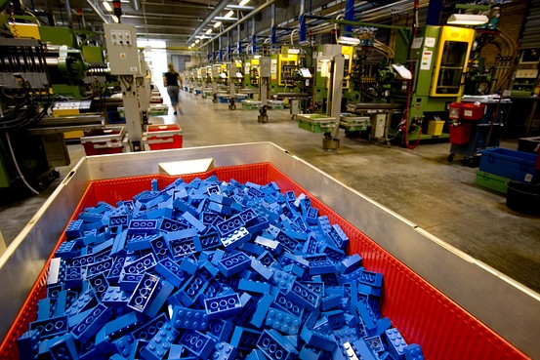
Lego analyzed data and arrived at a moment of clarity: They needed to "go back to the brick." David McLain/Aurora Photos/Corbis
Today Lego is again a successful company. The turnaround has many reasons, including the recent success of "The Lego Movie," but one of them is certainly a deeper understanding of the play experience.
Since its founding in 1954, Coloplast, a medical technology company based in Denmark, had grown by double digits every year. Suddenly, in 2008, the company missed its sales targets four times in a single year. Long the global leader in the niche market for stoma bags for personal hygiene after colon surgery, Coloplast found that its products were losing market share to the competition.
Coloplast's research and development team was focused on solving the problem of "leakage" in the stoma bags. Countless studies showed that people who experienced leakage would lose trust in the product and change to something else. The general assumption across the industry was that better adhesives equaled less leakage.
For years, the engineers at Coloplast had made incremental improvements to their products, adding new features or improving the adhesive. But it was no longer enough. To get a better sense of what the company could do to provide a superior product, they decided to immerse themselves in the world of the customer. Over the course of several months, our firm worked with them to collect, sort and analyze troves of Thick Data about their customers' world.
As the executives at Coloplast worked their way through the videos, photos and firsthand impressions, they could see the actual bodies of their customers and how their products worked in relationship to them. As one executive told us, "I could pick up the photographs and the diaries, page through them, feel them. This data has a completely different texture to it."
What dawned on the Coloplast team was that the adhesive wasn't the problem. Rather, what caused the dreaded leakages was a lack of fit to the patients' diverse and changing bodies. Many patients gained or lost a lot of weight following their surgery or developed scar tissue that made it difficult to keep the stoma bags in place.
Coloplast used this insight to create three different product categories for body types. Not only did this help stop the leakage problem, it gave the company a clear perspective and direction for future innovation.
Finally, consider the case of Samsung's TV business. In the early 2000s, Samsung's TVs looked like every other TV on the shelf. Samsung executives could sense that they were missing opportunities to stand out, but they didn't understand how to excite consumers. They needed to ask a bigger question about human behavior in a cultural context: "What does the TV mean in the modern household?"
We worked with Samsung to answer that question. Through hundreds of hours of interviews, videos and other artifacts, we helped the company identify crucial patterns. One interview subject said that he hid the television in a corner because he didn't like the way it looked; another said he wanted his TV to communicate "timelessness," like his meticulously crafted chair. To most people, we discovered, TVs aren't electronics. They are furniture.
From this essential insight, the Samsung team was able to develop a completely redesigned TV with an aesthetic closer to that of modernist furniture than clunky technology. They hid speakers and other eyesores. They changed the way TVs were sold, marketed and serviced. The resulting TV—now a piece of furniture—was a perfect marriage of form and function.
Working with Thick Data isn't straightforward, but the alternative is to outsource these complex business challenges to machines. Even with the magnificent computational power now at our disposal, sometimes there is no alternative to sitting with problems, stewing in them and struggling through them with the help of careful, patient human observation.
—Mr. Madsbjerg and Mr. Rasmussen are the authors of "The Moment of Clarity: Using the Human Sciences to Solve Your Toughest Business Problems," from which this essay is adapted. Their consulting firm is ReD Associates.

