Mind and Matter

Scientists Study Why Stories Exist

April 4, 2014 7:14 p.m. ET
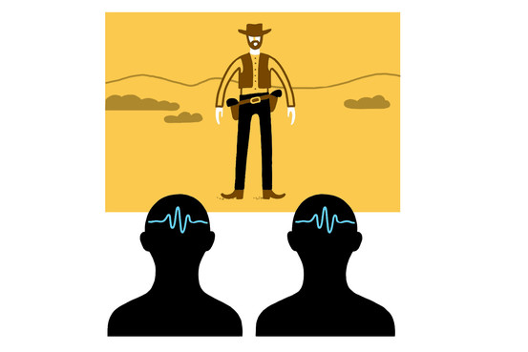
Luci Gutiérrez
We human beings spend hours each day telling and hearing stories. We always have. We've passed heroic legends around hunting fires, kitchen tables and the Web and have told sad tales of lost love on sailing ships, bar stools and cell phones. We've been captivated by Oedipus and Citizen Kane and Tony Soprano.
But why? Why not just communicate information through equations or lists of facts? Why is it that, even in talking about our own random, accidental lives, we impose heroes and villains, crises and resolutions?
You might think that academic English and literature departments, which are devoted to stories, would have tried to answer this question or would at least want to hear from scientists who had. But for a long time, literary theory was dominated by zombie ideas that had died in the sciences. Marx and Freud haunted English departments long after they had disappeared from economics and psychology.
Recently, that has started to change. Literary scholars are starting to pay attention to cognitive science and neuroscience. Admittedly, some of the first attempts were misguided and reductive—just-so stories from "evolutionary psychology" or efforts to locate literature in a particular brain area. But the conversation between literature and science is becoming more sophisticated and interesting.
At a fascinating workshop at Stanford University last month called "The Science of Stories," scientists and scholars talked about why reading Harlequin romances may make you more empathetic, about how 10-year-olds create the fantastic fictional worlds called "paracosms" and about the subtle psychological inferences in the great Chinese novel "The Story of the Stone." (You can find some of the talks here.)
One of the most interesting and surprising results came from the Princeton neuroscientist Uri Hasson. As techniques for analyzing brain-imaging data have gotten more sophisticated, neuroscientists have gone beyond simply mapping particular brain regions to particular psychological functions. Instead, they use complex mathematical analyses to look for patterns in the activity of the whole brain as it changes over time. Dr. Hasson and his colleagues have gone beyond even that. They measure the relationship between the pattern in one person's brain and the pattern in another's.
They have been especially interested in how brains respond to stories, whether they're watching a Clint Eastwood movie, listening to a Salinger short story or just hearing someone's personal "how we met" drama. When different people watched the same vivid story as they lay in the scanner—the movie "The Good, the Bad and the Ugly," for instance—their brain activity unfolded in a remarkably similar way. Sergio Leone really knew how to get into your head.
In another experiment, the Hasson team recorded the pattern of one person's brain activity as she told a vivid personal story. Then someone else listened to the story on tape, and they recorded his brain activity. Again, the two brain patterns showed a remarkable degree of correlation. The storyteller, like the film director Leone, had literally gotten in to the listener's brain and altered it in predictable ways. But more than that, she had made the listener's brain match her own.
The more tightly coupled the brains became, the more the listener said that he understood the story. This coupling effect disappeared if you scrambled the sentences in the story. Something about the literary coherence of the tale seemed to do the work.
One of my own favorite fictions, "Star Trek," often includes stories about high-tech, telepathic mind control: Some alien has special powers that allows it to shape another person's brain activity to match its own or that produces brains that are so tightly linked that you can barely distinguish them. Dr. Hasson's results suggest that we lowly humans are actually as good at mind-melding as the Vulcans or the Borg. We just do it with stories.

