Theory

Companies Turn to Social-Media Coaches

Consultants Offer Advice and Training to Those Hoping to Avoid Online Flubs

Updated March 26, 2014 9:49 a.m. ET
After several companies have been stung by social-media stumbles, a cottage industry of experts has emerged to help brands navigate the social-media landscape. Lindsay Gellman reports on digits. Photo: Twitter.com/SpaghettiOs.
Companies are hiring consultants for advice and skills that can spare them from becoming the latest casualty of a social-media flub.
View Graphics
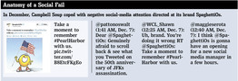
Many once shied away from engaging consumers on Twitter and Facebook. Now, as online chatter wields more power than ever to influence public sentiment, companies are hiring online monitors and making daily interactions standard practice.
The need for social-media crisis management has spawned a cottage industry that has firms like HootSuite Media Inc., SocialOomph.com, and Weber Shandwick offering monitoring software and services to deal effectively with online critics, react to events of interest to their markets and provide a positive glow to their brands.
ING Bank of Canada, which does business as ING Direct, last fall used a crisis simulation session to prepare for the public unveiling of the bank's new name, Tangerine Bank. The bank hired HootSuite to simulate a barrage of posts on Twitter and Facebook reacting to the new name, and to provide feedback on the team's response to the posts.
"We wanted to practice in advance of the game, which doesn't often happen in social media," said Jaime Stein, senior manager of social media at ING Direct, who oversees a staff of four. Mr. Stein said he told the HootSuite team to be "brutal" and not hold back in the drill.
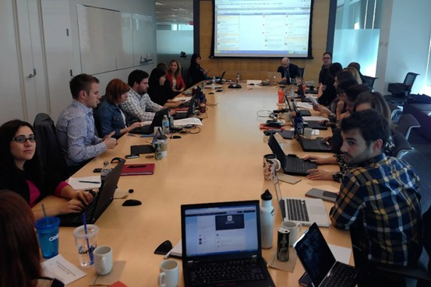
Workers at ING Bank of Canada participated in a social-media crisis simulation in advance of a name change. Jaime Stein
"Nice redesign," came a snarky tweet from a HootSuite staffer during the session. "I could have done that in my sleep. I'm sure you spent millions too."
Another: "I hate it."
The bank's communications team practiced measured responses. "Give it a chance, it might grow on you," ING Direct staffers tweeted back.
WSJD is the Journal's home for tech news, analysis and product reviews.
- Facebook to Buy Virtual-Reality Firm Oculus for $2 Billion
- Review: HTC One (M8): Best Android Phone Gets Even Better
- Is H-P Getting Its Mojo Back?
- Google Fashions Luxottica Deal to Bring Glass to Ray-Ban, Oakley
- Give Me Back My Online Privacy
It isn't just social-media teams worrying about these exchanges—top-level executives are taking note, too. Peter Aceto, chief executive officer of ING Direct, sat in on the HootSuite crisis simulation. He said he maintains active personal Facebook and Twitter accounts so that he can better gauge the nature of perceptions about the bank.
HootSuite said more corporate customers have been asking for war-room drills, which cost $15,000 a session. Past clients have included PPL Corp., a large energy and utility-holding company based in Allentown, Penn., and Guelph Hydro Electric Systems Inc. in Ontario, Canada.
Polpeo, the crisis-simulation arm of British social-media company Emoderation, charges between $20,000 and $40,000 for a similar session and use of the company's dummy social-media platforms. Public-relations firm Weber Shandwick, a unit of Interpublic Group, offers use of its own software, FireBell, as well as a mock-crisis session for about $50,000 and up, depending on the scope of the drill.
"You can't just stare at your belly button and think, 'My brand is great, everyone's going to love it,'" said David Gerzof Richard, founder of Boston marketing firm BIGfish and professor of marketing at Emerson College.
Nor can companies afford to stay silent during a crisis. General Motors Co. , which last month recalled 1.6 million vehicles to repair faulty ignition switches that have been linked to 12 deaths, has sought to engage individually with worried owners via Facebook and Twitter during the storm of bad publicity.
CEO Mary Barra said recently GM has deployed "communicators" to monitor websites and point customers toward GM resources. Since it already had a social media group, the auto maker added to its team rather than hire outsiders.
The group monitors about 100 websites at any given time looking for recall posts. It takes on average three hours to spot a comment posted somewhere other than the company's website, Facebook page or Twitter account. GM responds via the same outlet, such as Instagram, used for the original post, asking how the company might get in touch to discuss the issue.
Regularly monitoring social media and reacting quickly was a lesson Campbell Soup Co. recently learned. On the eve of Pearl Harbor Day last December, Campbell's posted an image of a smiling cartoon SpaghettiO holding an American flag on its SpaghettiOs Twitter account. "Take a moment to remember #PearlHarbor with us," the caption read.
Twitter users upbraided the brand for the awkward tie-in.
"Once we saw the reaction, we removed the tweet and apologized," a Campbell spokeswoman said. "We meant no harm."
Campbell since has worked to improve its social-media efforts, the spokeswoman said. The company recently created an office social-media "hub" comprising multiple screens that lets communications staff analyze public mentions of its brands, she said.
On the other hand, a clever social campaign and smart engagement can help re-energize a struggling brand. Retailer J.C. Penney Co. JCP +1.50% J.C. Penney Co. Inc. didn't air a commercial during this year's Super Bowl, but it grabbed online visibility for a line of winter mittens with a string of humorous tweets that were rife with misspellings.
After brands like Kia Motors and Coors responded to the scrambled tweets, implying that Penney's Twitter account was hijacked or drunk, Penney revealed that it was tweeting with mittens on, and showing images of its Team USA hand warmers.
The company, which didn't anticipate being linked with alcohol consumption, said it received over 130,000 Twitter mentions for the night, making it among the most-mentioned brands without a Super Bowl television commercial. "The buzz certainly exceeded our expectations," said a spokeswoman.
While the idea for the campaign came from Penney's social-media team, the company tapped social-and-digital agencies Evolution Bureau and Victors & Spoils to help execute it. The brand has since held on to the 10,000-plus followers it gained that night, she said, and mitten sales doubled after the tweets.
It is unclear how social-media followers translate to sales, but more followers generally means more visibility, said Jonah Berger, associate professor of marketing at the University of Pennsylvania's Wharton School. Social-media platforms also serve as a "barometer of the general sentiment that people have toward [a given] brand," he said.
When ING Direct disclosed its new name to the public last November, Mr. Stein says the social-media team received about 800 inquiries in the first six hours. But the staff felt prepared and remained calm, he said.
"Nothing that came at us was as bad as what the HootSuite team did to us," he said.
—Jeff Bennett contributed to this article.
Write to Lindsay Gellman at Lindsay.Gellman@wsj.com

