Apple's New Beat: What Steve Jobs and Dr. Dre Have in Common

Gangsta Rap Pioneer Is a Perfectionist and Workaholic Who Trusts His Gut Instinct
By
Hannah Karp

connect

June 6, 2014 3:01 p.m. ET
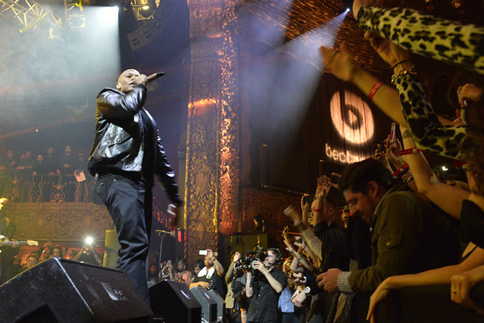
Dr. Dre, shown above in January, is a workaholic and like Apple's late founder Steve Jobs a perfectionist who often trusts his gut instincts. WireImage/Getty Images
As music mogul Jimmy Iovine and rap star Dr. Dre shopped their Beats Electronics headphone company and streaming service to Apple Inc., Mr. Iovine did most of the talking.
But behind the scenes, Dr. Dre—whose real name is Andre Young —has quietly played an equally powerful role developing and protecting the Beats brand, eschewing market research for gut instinct at every turn. Though his main obsession is perfecting the sound of the company's signature high-end headphones, the 49-year-old fitness-obsessed music producer weighs in decisively on everything from TV ads and font styles to the wordiness of descriptions on the Beats Music streaming service.
As one colleague says, Dr. Dre serves as Beats' "cultural barometer" of what is cool.
But Dr. Dre's process is mysterious, colleagues say: His assessments are usually immediate, personal and articulated sparely. He often dismisses ideas such as posing for clichéd photos in a recording studio as too "corny" or "cheesy." Or he'll wave them off with a terse "I'm not feeling that."
Dr. Dre's laconic style highlights his keen awareness of a universal dilemma, said Mr. Iovine: "Once you try to describe cool you run the risk of going perpetually to non-cool hell. The whole premise is not to talk about it."
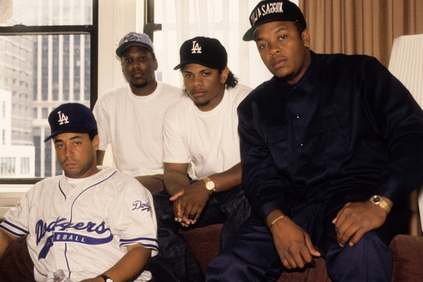
Dr. Dre, at far right, with other members of the gangsta rap group N.W.A. in 1991. Michael Ochs Archives/Getty Images

Dr. Dre's Greatest Hits
1986: Begins collaborating with rapper Ice Cube and joins gangsta rap group NWA
1992: Releases debut solo album, "The Chronic," on his co-owned Death Row Records label. Album goes on to sell nearly 8 million copies in the U.S.
1994: Wins his first of six Grammy awards for his rap solo on the single "Let Me Ride"
1996: Founds Aftermath Entertainment with financial backing from Interscope Records
2001: Produces the Grammy-winning rap album of the year, Eminem's "The Marshall Mathers EP," while taking home another Grammy for his own performance on "Forgot About Dre," from his second solo album, "2001"
2008: Launches high-end headphone company Beats Electronics with Interscope's chairman Jimmy Iovine
2013: Donates $35 million to the University of Southern California to create a new undergraduate program bearing his name [The Jimmy Iovine and Andre Young Academy for Arts, Technology and the Business of Innovation]
2014: Debuts Beats Music subscription streaming service and sells both Beats businesses to Apple for $3 billion
Dr. Dre's perfectionist impulse, coupled with his disregard for artificial deadlines, have meant that "he doesn't put out a lot of material," despite being a workaholic, said Paul Rosenberg, a lawyer and manager of one of Dr. Dre's protégés, rapper Eminem.
That could portend friction at his new employer, Apple, which agreed to buy Beats for $3 billion last month. But like Dr. Dre, Apple has also boasted about not doing market research. The company's late founder, Steve Jobs, made no secret of his belief that consumers don't really know what they want until someone else shows it to them. Colleagues predict that at Apple Dr. Dre could also cede some decision-making power and become more accommodating.
"What time should I show up for work?" he joked on a videoconference call to Apple's software engineering director, Craig Federighi, at Apple's Worldwide Developers Conference in San Francisco this week.
Dr. Dre, who declined to be interviewed or comment for this article, won't have a traditional job title at Apple—he and Mr. Iovine will be known on campus simply as "Jimmy and Dre," Mr. Iovine said last month. The company declined to comment about whether they will have contracts, though Apple is paying for the deal with $400 million in equity to create an incentive for the pair to stick around.
Apple Chief Executive Tim Cook said Dr. Dre would work with both Apple's hardware and music divisions as the company claws its way back to music's cutting edge, using its marketing muscle to expand the Beats electronics business and subscription streaming service under the Beats brand name.
Bringing a gangsta rap pioneer into the ranks of the squeaky-clean, image-obsessed tech company was a bold move for Mr. Cook, who hired Dr. Dre despite the violent, criminal subject matter and profane lyrics that define much of the rapper's oeuvre. Just last month, before Apple announced its acquisition, Dr. Dre appeared in a YouTube video with several friends, boasting about becoming "the first billionaire in hip-hop, right here from the motherf— West Coast."
But Apple has never censored the music it sells on its iTunes Store, while Dr. Dre has long been known to risk everything to do what he thinks is right, colleagues say.
After struggling through school in the economically depressed Los Angeles suburb of Compton and collaborating with gangsta rap group N.W.A. in his early 20s, Dr. Dre co-founded Death Row Records and released his debut solo album, "The Chronic," in 1992. He refused to make any changes to appease critical music executives and producers. It wasn't the voluminous profanity they objected to, but rather the rap record's unusually melodic, slow, funk-infused sound, which they said would flop. "The Chronic" went on to sell nearly 8 million copies in the U.S., according to Nielsen SoundScan, popularizing the new style that became known as "G-Funk."
Soon after, he founded his own label, Aftermath Entertainment, with financial backing and distribution from Mr. Iovine's Interscope Records, a division of Vivendi 's Universal Music Group. But it took nearly a decade before he released his second solo album, "2001," which has sold 4.6 million copies in the U.S. He has yet to finish his third album, "Detox," focusing his efforts instead on producing music for stars such as Eminem, Mary J. Blige, Jay Z and Kendrick Lamar. Two singles, ostensibly from the album, were released in 2010 and 2011.
As a producer, his reputation as a perfectionist grew. While working with Eminem, Dr. Dre would frequently gesture as if dumping liquid out of a container and say "you're pouring too much water in it," which was his way of encouraging the rapper to "keep it pure," said Mr. Rosenberg, adding, "Most of the time Dre gets the final word."
In 2008, with record sales in a years long free fall, Dr. Dre co-founded Beats Electronics with Mr. Iovine, creating what they hoped would be a more stable revenue source, since hardware isn't as easily pirated as digital songs. The men bonded over their views on sound quality but took different approaches to management. Mr. Iovine often talked to dozens of people he trusted before making a decision on a product or strategy and remained open to changing his mind.
Dr. Dre, a homebody, typically relied on personal intuition and rarely wavered, colleagues said. He is rarely seen at Beats headquarters, although he is often spotted running up outdoor staircases for exercise around Los Angeles.
On occasion Mr. Iovine and other executives have suggested running ads to broaden Beats' appeal beyond its core consumers, who are 55% male, brand-conscious and mostly younger than 24 years old, according to NPD Group analyst Ben Arnold. But Dr. Dre has resisted straying from the company's sound-centered, insider message, favoring TV ads such as one in which he tells Mr. Lamar, the hip-hop recording artist, after a hard day in the studio: "I figured it out: drums."
Dr. Dre has also obsessed over some of the details surrounding the Beats Music service, launched in January, which offers unlimited music streaming for $10 a month. After reviewing the musical lineup at the Beats Music launch party in Los Angeles, Dr. Dre nixed the plan, forcing artists such as Sean "Diddy" Combs and Nas to rearrange their schedules while insisting that Ice Cube kick off the show to set the night's tone. He himself called Ice Cube—his former N.W.A. bandmate—as no one else felt comfortable asking such a big star to be the opening act, said Mr. Rosenberg, who helped organized the performance.
On rare occasions, Dr. Dre is willing to bend. When Mr. Iovine asked basketball star LeBron James and his longtime business manager, Maverick Carter, to help develop a line of lighter-weight, wraparound Beats headphones for athletes, Dr. Dre was unwilling to compromise on the sound, presenting a challenge for designers. But Mr. Carter prevailed in one disagreement: He convinced the company to name the earphones "Powerbeats," over Dr. Dre's idea.
"It felt great," said Mr. Carter.
—Daisuke Wakabayashi contributed to this article.
Write to Hannah Karp at hannah.karp@wsj.com

