Business Day

Aiming at China’s Armpits: When Foreign Brands Misfire
By OWEN GUOFEB. 2, 2018
Photo
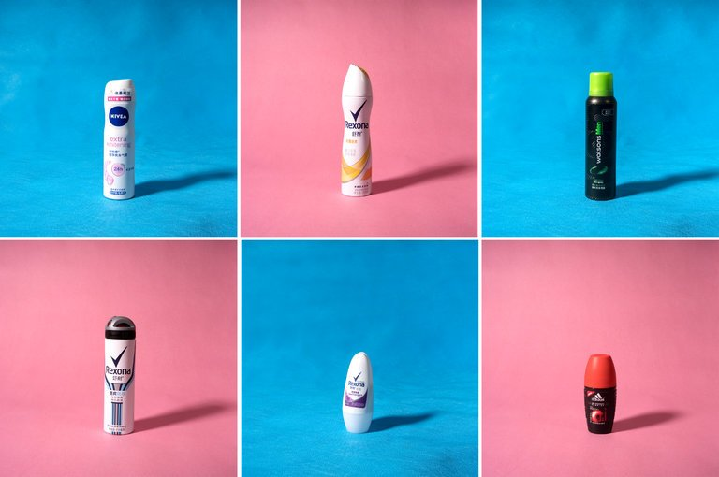
Because of cultural and biological differences, deodorants are a tough sell in China. Credit Giulia Marchi for The New York Times
BEIJING — Unilever brought its Rexona deodorant to China a decade ago, dreaming of a market with 2.6 billion armpits.
Wages were rising, consumers were spending and the run-up to the 2008 Beijing Olympics was making Chinese people feel more cosmopolitan. More of them, it stood to reason, would be open to a Western hygiene product.
“We had created established markets for Rexona from scratch in many countries, and we did not see any reason why we couldn’t do the same in China,” Frank Braeken, Unilever’s former China head, said by telephone from Dubai, where he now works as an investment consultant.
“We had an extremely ambitious plan at the time,” Mr. Braeken said.
But cultural differences and simple biology — scientists have shown that many East Asian people don’t have Westerners’ body odor issues — scotched those plans. Sales totaled only a fraction of the Chinese marketing budget for Rexona, Mr. Braeken said. Today, by some estimates, less than 10 percent of China’s population uses deodorant, and it can be hard to find outside major cities.
China’s growing consumer class has fueled global growth and lifted the fortunes of Starbucks, KFC and a host of other Western brands. Many Chinese people now drink coffee instead of tea, eat cheese and ice cream despite potential tummy tremors, and guzzle ice-cold sodas in a country where grandmothers express a mortal fear at any liquid below room temperature.

But the drive to win China’s consumers has had its notable failures.
Like tampons.
Most Chinese women use sanitary pads because they believe tampons are invasive. In 2016, China spent $136 million on tampons, only a fraction of the $4.9 billion annual sales for sanitary pads and towels in the country, according to data from Mintel, a consulting firm.
Procter & Gamble, the American consumer products company, gave up on Tampax in China in 2000, though it relaunched the brand last year. In a statement, Li Fengting, China director for the Tampax brand, said it had reintroduced the product in hopes of attracting a younger generation of women.
Then there’s Weetabix. Bright Food, a Shanghai-based company, bought a majority stake in the maker of the oblong staple of British breakfasts in 2012, hoping the cereal biscuits would find their way onto the Chinese family menu. It sold the stake to an American firm five years later, after what analysts said was a lackluster performance. A Bright Food spokesman, Pan Jianjun, said the decision to sell was part of the company’s international strategy but declined to comment further.
Companies like Apple and Starbucks have prospered in part by selling aspirational products to Chinese consumers who want to show the world that they have made it. That task is tougher for products that nobody sees.
“It has to be something visible or something you can smell,” said Ye Tan, an independent economist in Shanghai. “Deodorant fails partly because it is invisible.”
The products have their Chinese adherents. Cai Qianyi, a 38-year-old media professional in Beijing, started using deodorant in 2006, when he was studying in France. He doesn’t think he has body odor but sees a problem with sweat stains.
“Sweat leaving wet spots on your T-shirt in the summer is extremely ugly, especially around the armpits, which could be really socially embarrassing,” Mr. Cai said.
But most of his family and friends have no idea what deodorant is, he said. Once, a cousin mistook his deodorant stick for perfume and asked him why it was solid.
When global deodorant makers began their foray into China, they highlighted the social embarrassment caused by perspiration. Their central message was a proven winner in the West: Sweating will get you shunned socially and ruin your chances for romance.
That pitch fell on deaf ears in China, said Lucia Liu, a skin care assistant manager at Unilever who was involved in Rexona’s marketing between 2011 and 2016.
“The traditional thinking here is that sweating is good because it helps people detox,” said Ms. Liu. “There is a marketing barrier that is really hard to overcome.”
Indeed, Chinese health websites have long promoted the benefits of sweating, ranging from a boost in immunity to memory enhancement to skin rejuvenation. To many Chinese, perspiration is a natural part of metabolism that should not be blocked.
There’s another reason few Chinese consumers buy deodorant: basic biology.
Scientists in recent years have shown that many East Asians, a group that includes China’s ethnic Han majority, have a gene that lowers the likelihood of a strong “human axillary odor” — scientist-speak for body stink.
That lowers the likelihood that they will use deodorant to begin with, according to a 2013 study by researchers at the University of Bristol and Brunel University in Britain, after a survey of nearly 6,500 women of various backgrounds.
“It is likely that deodorant usage is not widely adopted because there is, for much of the East Asia population, no need for it,” it said. (For those curious about such matters, that same genetic difference also leads to drier earwax.)
Unilever was not deterred. It deployed a range of traditional marketing tools, including signing top celebrities to appear in TV ads, in-store product sampling and sweat tests, and concert sponsorships.
Many of its efforts seem tone deaf in retrospect.
A series of Rexona print ads portrayed a person’s armpits as potential threats to others. In one, a gunslinger — his armpit hovering over the scene in the foreground — appears to take down his opponent without touching his revolver. In a similar ad, a boxer appears to knock out his opponent with little more than his aroma.
Ng Tian It, a Singaporean creative director who oversaw the ad campaign, was proud of the look. But he said the ads appeared to be out of touch with many Chinese consumers unfamiliar with Old West shootouts, professional boxing and the prospect of offensive underarm smells.
“The series of advertisements we designed relied on the Western sense of humor,” he said. “Not many Chinese would understand this.”
Deodorant sales in the United States reached $4.5 billion in 2016, according to Euromonitor, a market research firm. China’s total: $110 million. Deodorant also does not sell well in other East Asian markets: Japan’s sales that year were about one-tenth those of the United States.
Companies hoping to sell deodorant in China have had to appeal to other senses. Nivea, a brand owned by Beiersdorf A.G. of Germany, has tried to lure female Chinese consumers by rolling out deodorants with whitening functions, to cater to a market where fair skin often confers social status.
Simon Cao, Nivea’s China marketing director, said that the deodorant was popular but that “the room for growth is very limited.”
“We will not spend too much energy on deodorant, because the investment is not proportional to the return,” he said.
The dearth of deodorants in China has forced some expatriates to hoard.
Alex Stevens, a 26-year-old American former public relations professional who left Beijing last year after living there nearly a decade, said he loaded up on deodorant every time he was back in the United States.
“It’s really become the only thing I stock up on when I go back home,” he said, “and I don’t give any away to friends, not even for a price.”
A version of this article appears in print on February 3, 2018, on Page B1 of the New York edition with the headline: Pursuing Armpits, and Whiffing. Order Reprints| Today's Paper|Subscribe

