Forget Dinner. It's Always Snack Time in America

More Consumers Forgo Traditional Meals in Favor of Snacks Several Times a Day—Roiling the Food Industry
By
Mike Esterl

connect

Updated July 1, 2014 7:01 p.m. ET
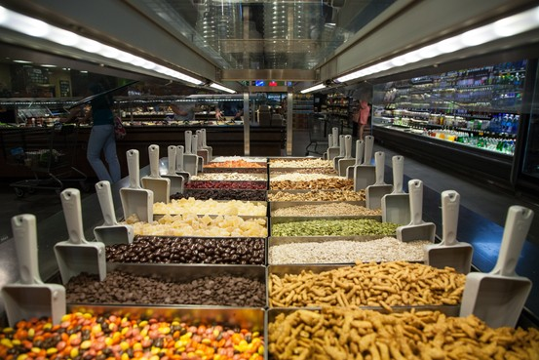
The percentage of Americans who say they snack three or more times a day rose to 56% by 2010, up from 10% in the late 1970s. Dustin Chambers for The Wall Street Journal
Lauren Campbell eats six times a day—and skips every single meal.
The 28-year-old Atlanta accountant fuels up every few hours on small servings of instant oatmeal, sliced chicken or microwavable brown rice. If she meets friends at a restaurant for dinner, she skips the entree. Ms. Campbell munches instead on snow peas stashed in her purse.
"I'm normally kind of full by then," she says.
Americans are becoming serial snackers. What started as grazing more than three decades ago has turned into willy-nilly consumption patterns, disrupting of the American diet of three meals a day and making the pillars of peanut-butter and jelly sandwiches for lunch and bacon and eggs for breakfast a part of the past—and roiling the food industry in the process.
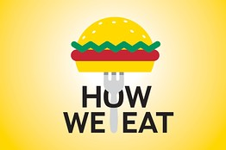
A continuing series about how consumer perceptions and corporate strategies shape the national diet.
Part One: The Gluten-Free Craze: Is It Healthy?
Part Two: Food Makers' Secret Ingredient: Less Salt
Part Three: The Problem With Portions
Part Four: America Renews Love Affair With Butter
Part Five: Frozen Foods Grow Cold as Tastes Shift to Fresher Fare
With fewer consumers sitting down for a bowl of cereal at breakfast time, Kellogg Co. 's overall sales dropped 3.1% last quarter. The maker of Special K and Rice Krispies is trying to adapt to changing eating habits by marketing its breakfast "To Go" products such as strawberry shakes.
Revenue at General Mills Inc. 's U.S. snacks division, whose brands include Nature Valley granola bars, Fruit Roll-Ups and Bugles corn snacks, rose 6% in its fiscal year ended May 25. Its U.S. meals division, which includes Hamburger Helper, Macaroni Grill and Old El Paso, contracted 4%.
"We are in changing times," General Mills Chief Executive Ken Powell told Wall Street analysts last month.
Once considered an indulgence—a few cookies or handful of potato chips—a snack now seems to be anything small, increasingly nutritional and portable that complements or replaces a meal.
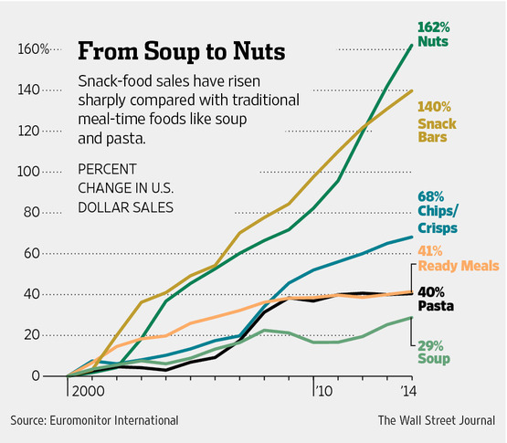
U.S. retail sales of soups averaged 0.4%, while pasta averaged 1.3% annual growth between 2008 and 2013, according to Euromonitor International. At the same time sales of chips rose 4.2%, and snack bars and nuts jumped 5.4% and 7.8%, respectively.
The practice of eating three meals a day surfaces in documents dating back to ancient Greece, although the Greeks didn't say why they settled on that number, according to Andrew F. Smith, who has written several books on food history and edited "The Oxford Encyclopedia of Food and Drink in America."
Snacking dates back only about 100 years, initially tied to fun and special occasions, with typical snacks including peanuts, popcorn or candied apples. "It really started at circuses and fairs," says Mr. Smith, who teaches food studies at the New School University in New York.
The Academy of Nutrition and Dietetics, which represents dietitians, says there isn't scientific consensus on whether it is healthier to eat three full meals a day or consume more frequent snacks. Snacking can be risky because it takes discipline. "That's where people tend to go wrong," says Marisa Moore, a registered dietitian and academy spokeswoman, adding a snack should be under 200 calories.
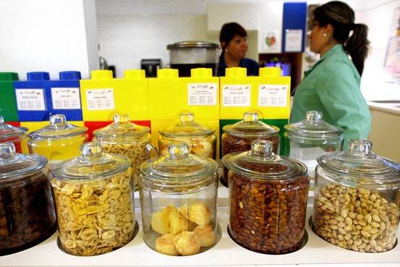
Jars are filled with nuts and other snacks at Google's New York office. The Washington Post/Getty Images
Today's snack revolution is driven by rapidly changing demographics: the rise in single-person households, the increase in baby boomers with empty nests and the increasingly hectic lives of two-career families. Demands on the kids have ramped up, too. Little League often trumps the family dinner. All that makes it tough to squeeze in time to eat a meal, let alone plan, shop or cook.
The percentage of Americans who snack three or more times a day rose to 56% by 2010, according to the latest available government data. That is up from roughly 20% in the 1990s and 10% in the late 1970s. "Snacking used to be an occasional thing, now it is just kind of daily life," says Laurie Demeritt, chief executive of consumer tracker Hartman Group. "There are fewer rules."
A 2013 Hartman survey found 48% of Americans skipped meals at least three times a week, and 63% decided what to consume less than an hour before eating.
Ms. Campbell, the accountant, says she lives alone and making a meal "seems pointless." But she also says replacing big meals with small snacks has helped her lose weight.
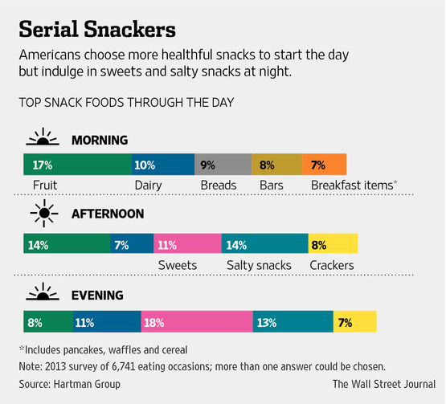
To accommodate consumers like Ms. Campbell, companies are repackaging all sorts of products into snack-size portions—advertising the nutritional content and calorie count. Kraft Foods Group Inc. earlier this year launched Oscar Mayer "portable protein packs'' including one with ham, cheese and almonds that has 160 calories but 25% of the daily recommended protein. General Mills last year introduced 140-calorie Fiber One Protein Chewy Bars with 10% and 20% of the daily recommended protein and dietary fiber, respectively. Pickles are now sold in mini snack packs.
Healthier snack categories posted outsize growth in 2013, with "nutritional snacks and trail mixes" volumes up 9.9% and carob-yogurt coated snacks up 26%, according to market researcher IRI.
Breakfast has experienced some of the biggest change. About one-third of Americans eat an early morning snack, up from 14% in 2010, and 55% eat a midmorning snack, up from 45% four years ago, according to a 2014 survey by IRI. The most-popular morning snacks are portable items like yogurt, bakery snacks and snack bars.
That has complicated business for big food companies. Suffering declining cereal sales, Kellogg this spring introduced flavored Eggo waffle bars that can be eaten from a pouch. PepsiCo Inc. PEP +0.58% PepsiCo Inc. 's Quaker unit, famous for its oatmeal, is test-marketing breakfast shakes with Wal-Mart Stores Inc

Tweet Us at #WSJSnack
Do you snack at work? Share photos of your top snacking choice, whether it's something easy to eat with one hand, leaving the other free to type, or something more indulgent. We will post selections of them online.
Tweet or Instagram photos of your favorite thing to snack on using #WSJsnack .
Dinner courses are getting a makeover, too. ConAgra Foods Inc sells 7.5 ounce microwavable bowls of Chef Boyardee lasagna, ravioli and spaghetti and meatballs, each at around 200 calories. Microwavable " Kroger KR -0.20% Kroger Co. Cups" by supermarket chain Kroger Co. also are roughly 200 calories and include beef stew, rice with chicken and vegetables, and dumplings and chicken.
Nestlé SA recently introduced Lean Cuisine "snack pizzas" and stuffed pretzels. It also is driving a truck around the U.S. offering free samples of 250-calorie Stouffer's macaroni and cheese "cups" ahead of their late-summer launch.
General Mills last November launched the online snack-delivery service nibblrbox.com to compete against the proliferation of sites shipping to homes and offices such as graze.com, boxtera.com and naturebox.com—the latter alone offering more than 100 snack varieties ranging from Guacamole Bites and PB&J Granola to Carrot Strawberry Fruit Chews and Bruschetta Pretzel Pops.
Meanwhile chips, long America's dominant salty snack, have expanded far beyond potatoes. At a Whole Foods Market Inc. WFM +0.36% Whole Foods Market Inc. U.S.: store in Atlanta, 25-year-old Mike Cato grabbed a bag of Snikkidy LLC's "eat your vegetables" chips that contain eight different vegetables including kale and promise a full serving of vegetables every ounce, or 13 chips.
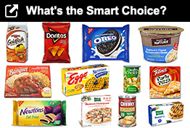
QUIZ: It isn't easy to judge food by its packaging. See how you score when it comes to selecting the smarter choices among these packaged-food match-ups.
Mr. Cato, a computer engineer, says he typically eats two meals, around 10 a.m. and 4 p.m., anything from curry or hummus to waffles, "whichever takes the least effort." He typically supplements that with three snacks a day, sticking to things like almonds, yogurt and vegetables.

Corporate Intelligence
- People Want Fast, Convenient Food. So Why Shun the Freezer Aisle?
- Cutting Out Sugar? Food Makers Do It in Secret
- Observations From L.A., Ground Zero of Gluten-Free Eating
- The Intersection of Low-Carb Diets and Giant Corporate Takeovers
- Kellogg Responds to the Rise of Yogurt: If You Can't Beat 'Em, Join 'Em
- In Low-Carb Age, Does Cereal Have Future?
PepsiCo, which makes best-selling Lay's potato chips, recently introduced Near East multigrain chips with couscous, quinoa and lentils. Also on the market are Keen Marketing and Manufacturing's Vintage Italia "pasta chips" made with semolina flour. Freeze Dried Partners LLC makes "Funky Monkey" chips from freeze-dried fruit.
While chips and fruit were the most-common afternoon snacks in Hartman's 2013 consumer survey, old-fashioned indulgences like candy and ice cream still reign as the most-common nighttime snacks.
Why? Because at the end of the day, says Hartman, consumers tend to lose their discipline.
Write to Mike Esterl at mike.esterl@wsj.com

