Can the Internet Save the Department Store?
Published
3 days ago
on
July 27, 2019
By
HDSN
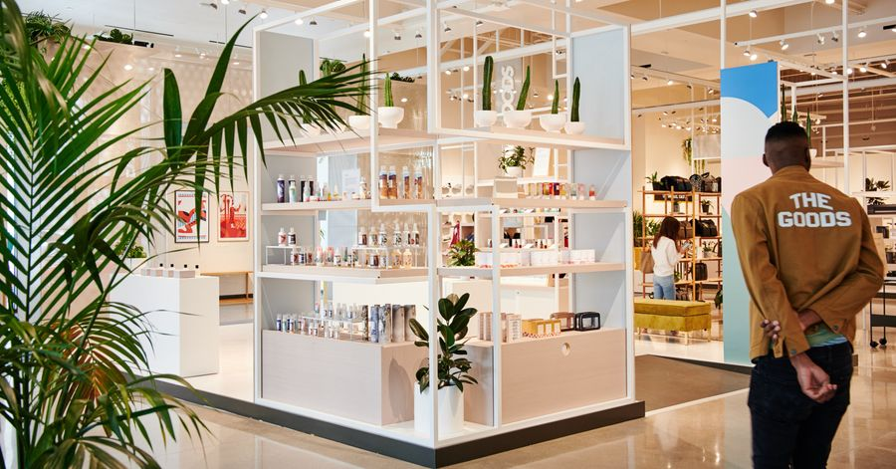

In the department store of the future, you can chat with hipster-ish brand advocates about erectile-dysfunction pills while sipping a cortado from the in-store cafe and perusing fashionable onesies from a brand that first found success on the internet and is just now appearing in “offline retail.”
When you’re ready to check out, you can complete your transaction on the store app. Like tracking an Uber, you can watch as your purchase winds its way to you in the hands of a salesperson, who knows right where you’re standing, thanks to centimeter-precise indoor-location technology.
This experience might sound like a flight of fancy, but it is one you can have today in Plano, Texas, at a store called Neighborhood Goods, which has the backing of investors who normally direct funds to tech companies rather than bricks-and-mortar retailers.
Even the detail about erectile-dysfunction pills is real: The men’s-wellness brand Hims, which sells prescription drugs online, offers goods such as multivitamins and wrinkle cream in the store.
An employee arranges clothing at Neighborhood Goods, a new kind of store selling primarily internet-first brands in Plano, Texas.
Photo:
JONATHAN ZIZZO for The Wall Street Journal
Neighborhood Goods is hardly alone in rolling out this new model. Experiences like this one are headed to other retailers near you.
“We think that what’s happening now with physical retail is the next generation of all commerce,” says Vibhu Norby, chief executive of b8ta, which specializes in consumer electronics at its 17 stores. A partner in the reboot of Toys ‘R’ Us, the company is also powering the software back end of
Macy’s
experiment in next-generation retail, called Market @ Macy’s. Other stores pioneering similar models include Bulletin, a store that focuses on female-founded brands; Showfields, which touts itself as “the most interesting store in the world”; and Camp, a kid-focused “family experience store.”
The retail future these companies are touting is at once bizarre and intuitive. It is based on the concept of the “marketplace”—in the sense that Amazon and other retailers are all becoming marketplaces that simply list others’ goods for a fee—except these stores are focused on an ever-shifting menagerie of internet-native brands.

Share Your Thoughts
Can the internet save the department store? Join the conversation below.
In the case of b8ta, brands essentially rent space in the stores, then keep all of what they make. This model isn’t new—the “store within a store” has been common in department stores for decades. In this revival, both brands and stores make money whether a shopper buys an item in the store or online. With the old retail model, if a shopper came into, say, a
Best Buy
and tried a Nest thermostat, and then decided to buy it online directly from Nest, Best Buy bore the cost of showing it to the consumer but reaped none of the reward. Whereas with this new model, online sales aren’t taking revenue from stores, which get paid by brands regardless of how much they sell.
The concept comes as retail landlords are at their most vulnerable. They’re seeing revenue crater as more stores close every day. Whole chains are succumbing to underinvestment, crushing debt loads, failure to innovate and the loss of business to Amazon and others online.
Compared with the cost of finding new customers through ever-more-expensive online advertising, paying someone to put your goods on a shelf in an actual store might look attractive.
All of this is so new, and it might not be sustainable. The only test beds thus far have been a handful of stores in major metros that can easily attract the kind of well-off, young, novelty-seeking demographic this is tailored for. Another challenge is that the same novelty that attracts people to these stores in the first place—the rotation of new brands every few months—could make repeat business difficult, as customers follow the brands they like to their permanent online homes.
The fluidity of how goods are sold and delivered in these newfangled stores shows just how much consumers have come to expect convenience and novelty, and the lengths retailers must go to satisfy them.
At the Neighborhood Goods store in Plano, most items can be bought off the shelf, as at a normal store, except that there are no cash registers, save one at the cafe. Shoppers scan bar codes into the store’s app, or ask one of the sales associates to do it for them, on their own mobile devices. And should the store run out of any particular item, shoppers can buy through the app and have it delivered to their home. This is the “endless aisle” advantage of physical storefronts attached to e-commerce operations, allowing them to get you goods quickly whether they’re in stock at that store or not.
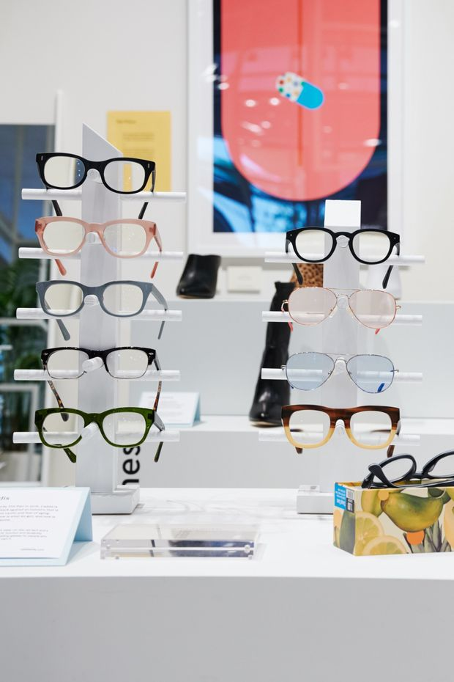
Neighborhood Goods, a new kind of department store, sells primarily internet-native brands like Caddis eyeglasses..
Photo:
JONATHAN ZIZZO for The Wall Street Journal
Later this year, Neighborhood Goods will open its second store in New York City. The company is currently looking for real estate in other U.S. cities, with plans for up to six more stores launching in 2020, and has raised a total of $14.5 million so far, says Matt Alexander, CEO of Neighborhood Goods.
To get people into the store in the first place, these stores are all about experience. B8ta has working demos of all the gadgets it sells in-store; Neighborhood Goods hosts exercise classes and events like watercolor workshops. Like any good Instagram or YouTube feed, the store operators are aiming for an enjoyable mix of content and commerce.
“If you look at the direct-to-consumer space on Instagram, and why’s it doing well, it is because they’re telling better stories,” says Mr. Alexander. “It comes down to human anxiety and a desire for identity.”
Another thing these stores have in common with the internet is a reliance on data. Neighborhood Goods uses in-store cameras from RetailNext to capture images of shoppers so that artificial intelligence can determine their age and sex, as well as generating heat maps of where they linger and what they buy. B8ta has developed its own software that manages all the inventory and sales for its goods, without which its tie-ups with large retailers like Macy’s would be impossible, says its CEO Mr. Norby.
The eventual goal is to make this experience the dominant model for all of retail. Companies like b8ta plan to roll out in every city, or at least force competitors to adopt their model and then license their software and inventory management systems.
“Basically every major retailer is considering initiatives like this,” Mr. Norby says. Some retail landlords are already experimenting with the concept. Shopping-center owner
Macerich
has launched BrandBox, and
Simon Property Group
has debuted The Edit.
Research shows that when products are showcased in a physical retail space, online sales of that same product increase, says Kit Yarrow, a professor of consumer psychology at Golden Gate University in San Francisco and author of “Decoding the New Consumer Mind.” In other words, physical retail, once the primary delivery channel for goods, is becoming its most powerful advertising channel. The sooner existing retailers can catch up to this reality, both in how they display wares and whether their model needlessly competes with online sales, the sooner they can reverse their decline.
“It is all integrated in the minds of consumers, but not yet integrated in the minds of retail executives,” says Dr. Yarrow.
Write to Christopher Mims at christopher.mims@wsj.com
For more WSJ Technology analysis, reviews, advice and headlines, sign up for our weekly newsletter. And don’t forget to subscribe to our Instant Message podcast.

