How Hotel Companies Launch a New Brand

A bumper crop of boutiques flood the market; tub or shower only? What goes in the minibar?
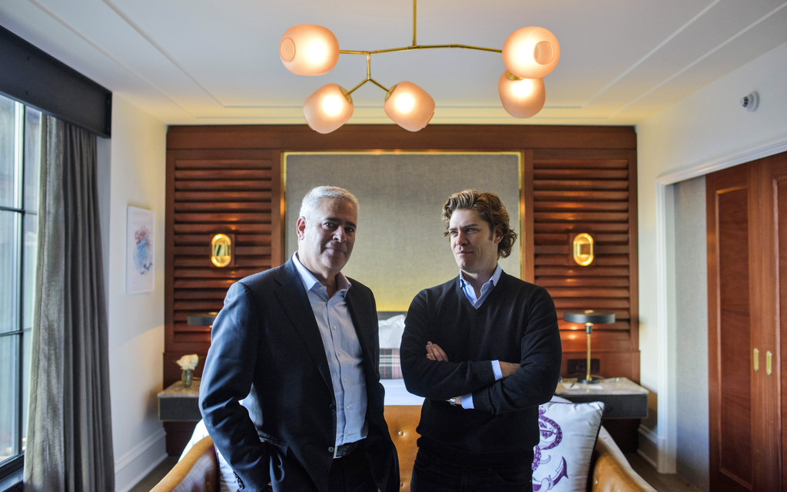
Father and son Alan (left) and Michael Fuerstman of Montage Hotels & Resorts show visitors the model room of their new Pendry brand’s Baltimore property. The room, done up in mahogany and brass, is designed to look like a ship captain’s berth. Photo: Matt Roth for The Wall Street Journal
By
Andrea Petersen

Dec. 31, 2016 10:36 a.m. ET
15 COMMENTS
Baltimore—Hotel company executive Alan Fuerstman is standing in a mahogany- and brass-adorned model hotel room here debating whether guests staying in outposts of his new brand, Pendry, should be provided slippers in their rooms.
Slippers or no slippers? Turndown service or no? Bathtub or shower only? These are just a few of the decisions that need to be made when launching a new hotel brand.
Travelers are about to see a flurry of new hotel brands. Pendry is the second one from Mr. Fuerstman’s Montage Hotels & Resorts, an Irvine, Calif.-based company which operates five luxury Montage hotels. Hyatt Hotels Corp. has launched seven new brands in the last decade, most recently Hyatt Centric—a “millennial-mindset-lifestyle” one featuring hair dryers from the blowout salon chain Drybar—in 2015 and the Unbound Collection by Hyatt—an assemblage of properties that maintain their own individual identities—in March of 2016. Hilton Worldwide Holdings Inc. will soon have 28 properties of its new Canopy brand of hip boutique-style hotels. (Staff are called “enthusiasts.” The general manager is the “chief enthusiast.”) The company is also opening its first Tru hotel, a lower-priced boutique brand, in 2017.
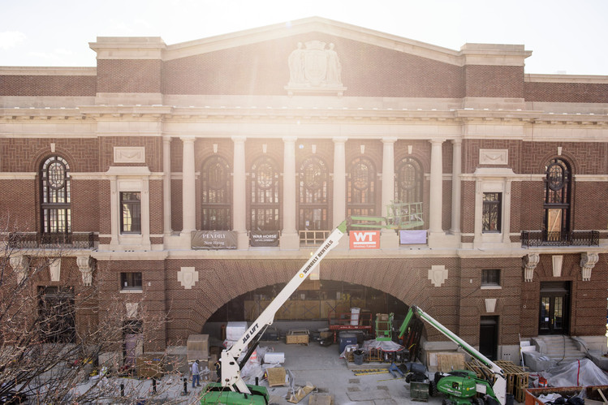
The Sagamore Pendry Baltimore hotel is housed in a refurbished historic pier and immigration center on the city’s waterfront. The hotel’s owner is Kevin Plank, founder of the fitness apparel company Under Armour. Photo: Matt Roth for The Wall Street Journal
Why the bumper crop of new brands? In many cities, the big hotel companies, like Hilton and Marriott International Inc., already have so many properties under their existing brands that they need to launch new ones to keep growing, says R. Mark Woodworth, senior managing director at CBRE Hotels’ Americas Research. After all, how many Residence Inns do travelers need in one town? Also, peoples’ tastes have changed and millennials are a growing percentage of customers, says Mr. Woodworth: They want hipper, more happening lobbies and restaurants and better technology in rooms. So hotel companies are creating new brands they hope will be more appealing to both travelers and real estate owners. Many hotel companies don’t actually own their properties. Instead, they franchise the brand or operate the hotels for owners.
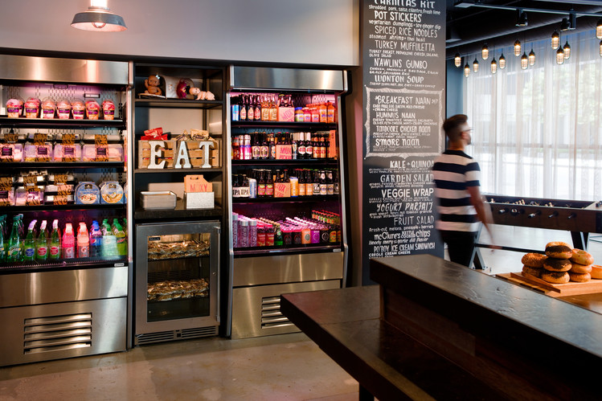
Marriott opened its first Moxy hotel in 2014. It has prices comparable to a Fairfield Inn but with the design and vibe of a W, says Toni Stoeckl, vice president of distinctive select brands. Moxy rooms are about 180 square feet. Marriott dubs customers of the brand “fun hunters.” Photo: Moxy Hotels
The hotel business is doing well these days. After struggling during the recession, occupancy rates rose to 65.4% in 2015, up from 57.6% in 2010, according to STR, a company that tracks and analyzes hotel data. The average daily rate jumped to $120.30 from $98.06 during the same time period.
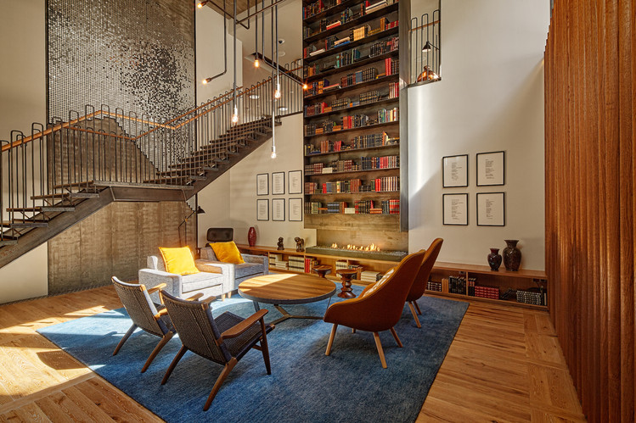
When Hilton was choosing the name for its new Canopy brand (the Reykjavik, Iceland property shown here), the company considered more than 100 options. “Script” was another top contender. Photo: Canopy/Hilton
Mr. Fuerstman, founder and chief executive of Montage and his son, Michael Fuerstman, decided to launch Pendry when they found themselves having to turn down potential deals to open new Montage hotels. To successfully operate Montages, which are in prime locations and have lavish spas and large guest rooms, the Fuerstmans say they need to charge at least $600 per room per night on average. But there aren’t too many destinations where travelers will pay that kind of price. Pendry hotels, by contrast, will have rates generally between $300 and $500 per night. The first two Pendrys will open in San Diego in January and Baltimore, on a refurbished historic pier in the trendy Fell’s Point neighborhood, in March of 2017.
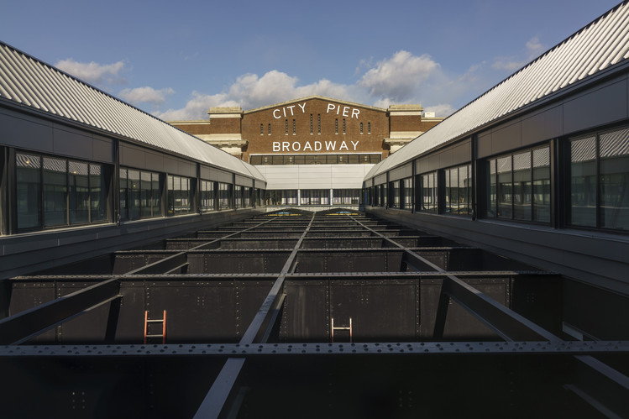
During construction on the pier, workers at the Pendry in Baltimore unearthed three old cannons. One will be placed under a glass panel in the floor of the hotel’s bar; the other two will be at the entrance. Photo: Matt Roth for The Wall Street Journal
Pendrys will have more amenities than the typical boutique—there’s bell service, 24-hour room service and concierges—but with a funkier design and hipper vibe than traditional luxury brands: San Diego will have a nightclub and a beer hall; Baltimore will feature a whiskey bar. When the Fuerstmans were dreaming up the brand, they had a target traveler in mind, a “mid-30s, active, affluent, engaged, well-traveled guest,” says Michael Fuerstman, the Pendry brand’s 33-year-old co-founder and creative director. They also had a motto: “Know Thyself.” But they didn’t yet have a name. Michael Fuerstman says he Googled “Know Thyself” and “somehow found this house of Pendry in the far recesses of the Internet,” he says, a British noble family whose motto was also “Know Thyself.” (Montage was able to trademark “The Pendry” and soon hopes to drop the “the.”)
The Fuerstmans consulted an advertising firm, who urged them to create a fictional Mr. Pendry character, the globetrotting son of a British nobleman and a California surfer girl, to be the brand’s mascot. But they ultimately ditched him. “I didn’t want to create a fake face of the brand,” says Alan Fuerstman, 60, who started working in the hotel business as a doorman in high school in New Jersey.
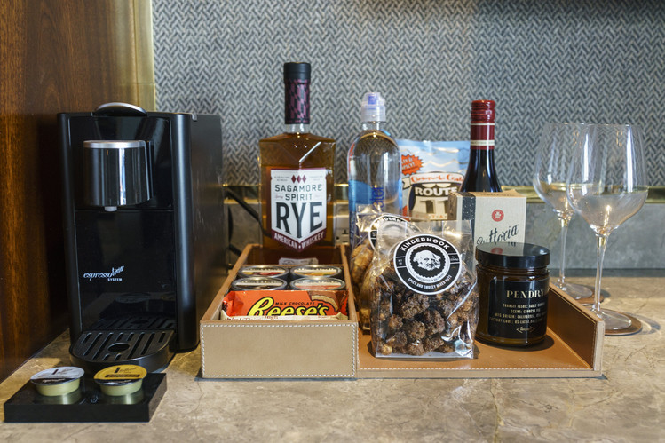
Pendry’s minibars feature products from Australia’s Vittoria Coffee and some local purveyors. Unlike the minibars at Montages, Pendry’s are automated and charge guests automatically when they remove an item. This cuts down on labor costs but can annoy travelers. Photo: Matt Roth for The Wall Street Journal
Since then, they have been figuring out the details of the new brand—and which aspects of Montage they’ll include and which they’ll need to skip to stay on budget. Pendry will have turndown service and the same beds and sheets as Montage. But, while guests are routinely escorted to their rooms at Montages, they won’t be at Pendrys. And while Montages have two sinks, a bathtub and shower, Pendrys will generally have just one sink and no bathtub.
As for the slippers, Michael Fuerstman says the property in San Diego won’t have them in the rooms because its competitors don’t—and it will save money. In Baltimore, however, he expects to compete most fiercely with the Four Seasons Hotel Baltimore, which opened in 2011. Whenever he has stayed at the Four Seasons, he found slippers in his room. So the Sagamore Pendry Baltimore will have them in the rooms too.
Write to Andrea Petersen at andrea.petersen@wsj.com

